Review for PhD applicants 2020

1. **Introduction**

Accrual accounting recognizes transactions based on their economic content by smoothing temporary timing differences between cash flows and operating performance. Dechow (1994) shows that this “noise reduction” or the timing role of accruals introduces a negative correlation between current period accruals and current period cash flows from operations - an implication that is almost taken for granted in the accounting literature. Recently, however, Bushman, Lerman, and Zhang (2016) provide compelling evidence that this negative correlation has diminished drastically over the last two decades. This result raises fundamental questions about whether accrual accounting has lost some of its usefulness over time. Indeed, Bushman et al. (2016) note that “*Both economic and reporting developments have led to the dramatic decline in the relative prominence of this timing role.*”

In this paper, we examine whether financial analysts, as sophisticated information intermediaries, perceive a decline in the timing role of accruals. Our motivation stems from the finding in Bushman et al. (2016) that increases in the frequencies of one-time “non-operating” items, write-offs, early recognition of unrealized losses, etc. are the primary reasons for this decline.[1] Such accruals do not serve a timing role as they are not associated with operating cash flows. A question that naturally arises is: Is it the case that the timing role of accruals has declined over time, or have these non-recurring non-operating accruals simply clouded inference about the *true* correlation between cash flows and operating accruals that, by design, are intended to serve a timing role?

Evidence in Nallareddy, Sethuraman, and Venkatachalam (2017) suggests the timing role of operating accruals may have indeed declined over time. They report that operating cycles and the magnitudes of working capital accruals have declined over time, reflecting, perhaps, the fast pace in which business processes have adapted to the advent of digital and internet age. To the extent such changes reduce the timing differences between cash flows and accounting recognition, operating accruals and deferrals would arguably serve less of a role as an inter-temporal smoothing mechanism.

However, one-time accruals such as recognition of losses that make up the difference between operating income and pre-tax income, as well as other non-recurring items such as stock option expenses, are fundamentally different in nature from operating accruals. These accruals, unlike operating accruals, have arguably little predictive ability with respect to future cash flows (Gu and Chen 2004). It is reasonable to expect that their inclusion (when testing the association between accruals and cash flows) will dampen our assessment of whether and to what extent operating accruals play a timing role. That is, it appears necessary to remove the effects of one-time non-timing related accruals in assessing the over-time trend in the timing role of operating accruals.

One approach to this issue is to diligently identify all non-recurring items for each firm and back them out of total accruals. This task is tedious if not impossible and is prone to measurement error because the nature of these accruals is likely to vary from firm to firm. Therefore, we approach this issue from the perspective of financial analysts who are sophisticated financial intermediaries and are considered to have the expertise to see through the noise introduced by non-timing related accruals to extract information useful for forecasting (Schipper 1991). Indeed, Gu and Chen (2004) provide evidence that analysts contributing to First Call exclude most non-recurring items from their measurement of “street” earnings. They also show that these exclusions have little predictive ability with respect to one-period ahead cash flows. Thus, if non-timing related items do not have the predictive ability for future cash flows (as we would expect), analysts should exclude them for forecasting purposes.

Our goal in this paper is to address the following research questions. To begin with, do analysts’ forecasts appear to rely on the information contained in accruals? With reported accruals becoming noisier, does the extent to which analysts rely on reported accruals to form their forecasts appear to decline over time? Do analysts’ forecasts of cash flows and forecasts of accruals (derived from earnings and cash flow forecasts) bear a negative relationship that is consistent with the timing role of accruals? Does this negative relation also decline over time as realized accruals have become noisier? To address these questions, we analyze a sample of firms for which financial analysts issue both earnings and cash flow forecasts (i.e., forecasts of cash flows from operations). This sample offers a unique advantage because we can back out forecasts of accruals from these two forecasts, which arguably only reflect informationally relevant portions of accruals. Therefore, using forecasted accruals and cash flows, we can better assess the role of accruals in smoothing the timing differences between cash flows and operating performance over time.

We begin our analysis by verifying that the results of Bushman et al. (2016) hold in our sample. We first find, similar to results documented by Bushman et al. (2016), that the negative correlation between cash flows and accruals declines over time. We next examine whether this trend holds in our sample of firms for which analysts issue forecasts of cash flows and earnings. Even in this sample, we find that the over-time declining negative association between reported accruals and reported cash flows documented in Bushman et al. (2016) comes through.

If analysts perceive accruals to have lost their usefulness over time, we should also expect to see an over-time decline in the analysts’ reliance on accruals for predicting future cash flows. Accordingly, we examine how analysts’ forecasts of one-period ahead cash flows incorporate information contained in both the current period’s reported cash flows and current period’s reported accruals. In a regression of the forecast of one-year ahead cash flows on the current period reported cash flows and accruals, both these variables are statistically significant. More importantly, while the coefficient on cash flows exhibits an increasing time trend, we do not detect a decreasing time trend in the coefficient on accruals. These results indicate that analysts’ reliance on accruals has not declined over time.

The timing role of accruals implies a negative correlation between current period accruals and current period cash flows from operations. As noted earlier, Bushman et al. (2016) show that the increasing frequency of one-time accruals has obfuscated this negative association over time. Under the premise that analysts can filter out the noise introduced by these one-time accruals, we examine the over-time trend in the contemporaneous association between forecasted cash flows and forecasted accruals. Our results indicate that this association is negative and statistically significant, with no appreciable time trend. Thus, our results are consistent with analysts being able to undo the noise in the accrual process. Their accrual forecasts do not appear to reflect any decline in the timing role of accruals.

These results do not, however, speak directly to the predictive ability of accrual forecasts. Analysts may fail to recognize a decline in the timing role of accruals, because of which their accrual forecasts may lose predictive power over time. To address this issue, we examine whether analysts’ accrual forecasts fare well in predicting future cash flows by regressing realized cash flows of a year on the analysts’ cash flow and accrual forecasts for that year. Our results indicate no significant time trend in the coefficient on cash flow forecasts, but, interestingly, the coefficient on accrual forecasts exhibits a significantly *increasing* time trend. Moreover, the incremental contribution of accrual forecasts in explaining realized cash flows also exhibits a significantly increasing time trend.[2] Thus, we see no evidence of a loss in the predictive power of analysts’ accrual forecasts over time.

We recognize that analysts issue cash flow forecasts for only a subset of firms for which they issue earnings forecasts. DeFond and Hung (2003) show that analysts tend to forecast cash flows for firms with large accruals, heterogeneous accounting choices, high earnings volatility, high capital intensity, and poor financial health. Consequently, our analyses and inferences are subject to self-selection concerns. To address this issue, we model the analysts’ decision to issue cash flow forecasts in a first stage Probit regression using determinants identified in DeFond and Hung (2003), allowing to control for self-selection in our second stage regressions. Our results and inferences remain qualitatively the same.

In related literature, Nallareddy et al. (2017) also investigate the changing landscape of accrual accounting and present evidence on the over-time trend in the relative predictive abilities of reported cash flows and accruals for future reported cash flows. They show that the predictive ability of cash flows has increased over time, but that of accruals has not. In this paper, we do not focus on the relative predictive abilities of cash flows and accruals because we are interested in the timing role of accruals as perceived by financial analysts. Our focus is also distinct from the vast literature motivated by the accrual anomaly documented in Sloan (1996), which examines whether analysts under-react or over-react to accrual information (e.g., Yu 2007). Our analysis differs from this literature because we examine how analysts use accrual information to predict future cash flows rather than future earnings, which include future accruals. That is, our objective is not one of assessing whether analysts can predict the persistence of accruals accurately.

In sum, our paper contributes to the understanding of whether accrual accounting is useful to sophisticated users of accounting information in predicting future cash flows and whether this usefulness has declined over time due to the changing landscape. Our results show that sophisticated users of financial information use outputs of accrual accounting in their decision-making process. We not only find that analysts’ forecasts of future cash flows incorporate information contained in current period accruals, but also find that analysts’ forecasts of accruals have significant predictive value. More importantly, we find that the analysts’ use of accruals has not diminished over time, or, equivalently, analysts’ forecasts do not reflect a decline in the predictive ability of accruals. Finally, under the reasonable premise that analysts can filter out any noise in accruals attributable to non-timing related items, we do not find any over-time decline in timing or the noise reduction role of accruals.

Collectively, our results suggest that the operating accruals that are intended to serve a timing role have not lost their usefulness at least as perceived by financial analysts. Financial analysts are sophisticated financial intermediaries who interpret, process and disseminate relevant financial information to capital markets. Given that financial analysts can be viewed as representative of the group to whom financial reporting is and should be addressed (Schipper 1991), our findings suggest financial statement users still find accrual accounting useful in assessing the firm’s cash flows because accrual accounting preserves its core function of mitigating the timing problem of cash flows.

The paper proceeds as follows. Section 2 provides some background and a brief review of relevant literature. Second 3 describes the data. We present our main results in Section 4 and present some additional tests in Section 5. Finally, Section 6 provides a discussion and summary.

**2. Literature review**

FASB Concept 8 explains why accrual accounting is a better system of accounting than is cash accounting: “*Accrual accounting depicts the effects of transactions, and other events and circumstances on a reporting entity’s economic resources and claims in the periods in which those effects occur, even if the resulting cash receipts and payments occur in a different period.*” (paragraph OB17)”

Accrual accounting’s advantage arises from its ability to smooth out temporary timing fluctuations in operating cash flows (Bushman et al. 2016). Compare two firms which are similar in all respects, except, one firm (firm A) pays its supplier on time, and the other firm (firm B) delays its payment beyond the year-end. Under accrual accounting, firm B will have a higher balance in accounts payable than will firm A. Firm B will have a positive, income increasing accrual than will firm A, and firm B will pay its supplier in the next year which results in lower cash earnings in the next year. Thus, net income under accrual accounting will be the same for both the firms, however, for firm B accrual accounting smooths out the cash flow timing difference and leads to a positive relationship between the current period’s accruals and the future period’s cash flows. The ability of accrual accounting to reduce noise results in accrual accounting-based earnings being less volatile than cash accounting-based earnings. That said, accrual accounting involves making estimates and accruals are therefore subject to estimation errors. All else equal, such estimation errors could potentially lessen the smoothing role of accruals mentioned above.

Using a balance sheet and income statement approach to calculate cash flow from operations, early studies show that the contemporaneous relationship between cash flows and accruals is significantly negative.[3] Rayburn (1986) documents a negative correlation between cash flow from operations and accruals to be -0.81. In recent years, however, researchers have documented a lower level of correlation between current period cash flows and current period accruals. For example, Barone and Magilke (2009) document a Pearson correlation of −0.04 between levels of operating cash flows and total accruals. Bushman et al. (2016) show that the correlation between current period cash flows and current period accruals is -0.14 (Pearson correlation). However, they also document that the magnitude of this correlation has been decreasing over time. As noted earlier, Bushman et al. (2016) attribute this decline to the increasing frequency of non-operating accruals over time.

Our analysis is based on the premise that financial analysts can filter out the effects of non-operating accruals to discern the underlying properties of operating accruals. Indeed, Schipper (1991) observes: *“It makes sense to study analyst decision processes because analysts are among the primary users of financial accounting information ….. Given their importance as intermediaries who receive and process information for investors, it makes sense to view analysts – sophisticated users – as representative of the group to whom financial reporting is and should be addressed.”*

There is substantial evidence suggesting that financial reporting in its current form, i.e., accrual accounting, is a primary source of information to analysts. Using a survey methodology, Benjamin and Stanga (1977) show that analysts place high importance on several financial statement items. They document that both loan officers and financial analysts rank highly the usefulness of basic financial statements, segment information, fineness of expense reporting, detailed information on leases, and other significant transactions. Using a content analysis of financial analysts’ written reports, Breton and Taffler (2001) show that other than using financial statements in the annual report, analysts also make use of non-financial information such as firm strategy and quality of management. Bence, Hapesh, and Hussey (1995) use cluster analysis within an interview framework and show that analysts tend to use regular financial information in their decision-making process, whereas, institutional investors use both financial and non-financial information when making their trades.

More to the point, Gu and Chen (2004) show that analysts have the expertise to recognize which non-recurring items introduce noise in the accrual process and to exclude these items from their forecasts. Consequently, cash flow and earnings forecasts present us with an opportunity to seek additional evidence on the timing role of accruals as perceived by analysts.[4]

**3. Data and Descriptive Statistics**

We begin our analysis by verifying the results of Bushman et al. (2016) with respect to the timing role of accruals. For this purpose, we build a sample close to their sample beginning in 1964 and ending in 2014, and closely follow their sample selection procedures.

(Insert Table 1 here)

Table 1 describes the selection criteria and the attrition of observations due to requiring cash flow forecasts from analysts and other filters for our primary sample. We start with the universe of COMPUSTAT and IBES firm-year observations for the period 1964 to 2018. We drop firm-years with missing or negative total assets and with revenue less than $5 millions, which leaves us with 344,868 firm-year observations. Following Bushman et al. (2016), we also drop firm-year observations belonging to the financial sector (firms with SIC between 6000 and 6999) and firm-year observations affected by significant mergers and acquisitions activities (i.e., the ratio of sales from mergers and acquisitions to net sales over 5%). In addition, we limit firm-year observations with non-missing earnings, accruals, and cash flows. The sample verifying the results in Bushman et al. (2016) consists of 247,019 firm-year observations between 1964 and 2018.

The sample for our primary analysis using analyst forecasts starts in 1995 because cash flow forecasts made by analysts are sparse before 1995 (hereafter, the *primary* sample). Out of 247,019 observations in COMPUSTAT, we are left with 127,522 firm-year observations after 1995. We then merge the COMPUSTAT data (127,522 firm-year observations) with analyst earnings forecast data from IBES, and we are left with 88,515 firm-year observations. To construct the analysts’ accrual forecasts, we require firms to have both analyst cash flow forecasts and earnings forecasts. This further reduces our sample to 33,851 observations. 33,851 observations is our primary sample to test the timing role of accruals as reflected in analyst forecasts of cash flows and accruals.

Appendix A describes the variables we use in our analysis. Specifically, we define *EARNt*as earnings before extraordinary items (*IBC*) scaled by total assets (AT) at the beginning of period *t*. If *IBC* is missing, we substitute *IB* in its place. We define *CFOt* as cash flow from operations less extraordinary items (*ONACF* - *XIDOC*) deflated by total assets at the beginning of period *t.* *TACCt*is defined as earnings less cash flow from operations (*EARNt*- *CFOt*) deflated by total assets at the beginning of period *t*. For tests using firm-year observations prior to 1988 (i.e., pre-SFAS 95 periods), we use the balance sheet approach to compute total accruals because firms were required to disclose the statement of cash flows only after SFAS 95 came into effect. Specifically, for firm-year observations prior to 1988, we compute total accruals as changes in current assets (excluding cash) less changes in operating liabilities less depreciation expenses, deflated by total assets at the beginning of period *t*.

We obtain analyst forecasts of earnings and cash flows from operations from IBES. During each period *t*, we identify the earnings announcement date (EAD*t*-1) for period *t*-*1*. Next, we accumulate all the forecasts issued by each individual analyst for period *t*. These forecasts have to have been issued between EAD*t-1* – 110 days to EAD*t-1*+ 10 days. We keep the latest forecast issued by each individual analyst from the above set of forecasts. The median forecast from the reduced set of latest forecasts, divided by the total assets per share at the beginning of period *t*, is called the median consensus forecast for period *t*. If the median consensus forecast is missing because individual analyst data is missing, then, we substitute it with the latest IBES reported median consensus forecast prior to EAD*t-1*+ 10 days. This method is similar to that employed by Jennings et al. (2019). *Fc(CFOt)* is the consensus analyst cash flows forecast and, *Fc(EARNt)* is the consensus analyst EPS forecast. The difference between *Fc(CFOt)* and *Fc(EARNt)* is our measure of forecasted total accruals, *Fc(TACCt)*. To avoid undue influence of outliers, all continuous variables are winsorized at 1% and 99%.

(Insert Table 2 here)

Table 2 presents descriptive statistics of all relevant variables. To facilitate comparison, we present the statistics for the sample period of 1964-2014 analyzed in Bushman et al. (2016) in Panel B of the table, and we also reproduce these statistics as reported by Bushman et al. (2016) in Panel C. Comparing Panels B and C, we see that there are some differences in the number of observations for different variables. These differences are to be expected given that these differences could arise due to the backfilling procedures that COMPUSTAT is known to use to populate the database. Across the sample, the means are of the same order of magnitude for all variables except EARN, which appears to be markedly different. However, the median values of all variables including EARN appear fairly close across the panels.

Our primary sample of interest includes only those observations for which analysts’ forecast of cash flows are available, and the descriptive statistics of the variables in this sample are presented in Panel D. Comparing Panels A and D, we can see that the primary sample has different earnings, accruals, and cash flow profiles compared to the full sample described in Panel A. In particular, the mean earnings are higher although the median earnings are almost of the same order of magnitude. The mean and median accruals are more negative for the primary sample, while the mean and median cash flows are higher in the primary sample. It is possible that the primary sample has a systematically different profile than the full sample because analysts issue cash flows forecasts for select firms (DeFond and Hung 2003). We address the ramifications of this self-selection later in the paper.

**4. Empirical results**

Our research question seeks to answer whether analysts use reported cash flows and accruals in the prior period to predict cash flows for the current period. Further, we test whether forecasts of cash flows and accruals would better predict future reported cash flows than does reported cash flows from operations and accruals.

*4.1 Contemporaneous relationship between reported cash flows and accruals*

We begin our analysis by verifying the results of Bushman et al. (2016) regarding the negative association between contemporaneous accruals and cash flows. We estimate the following equation each year:

*TACCt* = *β0* + *β1 CFOt* + *εt*, (1)

As previously defined, *TACCt* is total accruals in period *t*, and *CFOt* is cash flow from operations in period *t* (see Appendix A for definitions). Columns 1-3 of Panel A in Table 3 report the results from estimating equation (1) for our full sample spanning from 1964 to 2018. In Columns 4 and 5, we reproduce the results from Bushman et al. (2016) for convenient reference. As we can see from comparing the Columns 1 and 4, the β1 coefficient estimates are similar in magnitude in most years across the two studies. In 38 out of 51 years, the difference in magnitude is less than 0.100. Moreover, the sign of the coefficient is consistent across the two studies in almost all years. Comparing Columns 3 and 5, the adjusted R2 are also of similar magnitudes in most years.

(Insert Table 3 here)

Consistent with Bushman et al. (2016), we find that the absolute value of the negative correlation between contemporaneously reported accruals and cash flows has been declining over time (i.e., becoming less negative). We also note that the adjusted R2 for equation (1) has been decreasing over time. Panel A of Figure 1 illustrates the time trend of the correlation between cash flows and accruals, and adjusted R2 documented in Columns 1 and 3 of Panel A in Table 3. The blue (red) line represents the regression coefficients *β1* (adjusted *R2*) using our sample. The figure shows that both the absolute values of the coefficient *β1* and adjusted *R2* decline over time, suggesting that the negative correlation between accruals and cash flows has been disappearing.

Similar to Bushman et al. (2016), we evaluate the decreasing trend statistically by regressing the estimated coefficients (or adjusted R2) on *Time Trend*, which is defined as the number of years since 1964. Similar to Bushman et al. (2016), *t*-statistics for the *Time Trend* variable are adjusted for Newey-West autocorrelations of three lags. The estimated coefficients on the *Time Trend* variable are reported at the bottom of Panel A in Table 3. We find that the *Time Trend* coefficient for the correlation between accruals and cash flows is 0.018 (*t*-statistic = 13.370). This result is very similar to the result documented by Bushman et al. (2016). There is also a significant reduction in the explanatory power of the model over time. The *Time Trend* coefficient for the adjusted *R2*is equal to -0.016 (*t*-statistic = -13.270). These results confirm what Bushman et al. (2016) find---that the negative association between reported accruals and cash flows has declined markedly over time.

We next re-estimate equation (1) to examine whether the results described in Panel A of Table 3, hold for our primary sample, where analyst forecast of cash flows are also available. We report the results from the estimation for the primary sample in Panel B of Table 3. As we can see from Panel B, there is a steady decline in the negative association between accruals and cash flows. This decline is also illustrated in Panel B of Figure 1. The time trends of *β1* and adjusted R2 of estimating equation (1) in the primary sample are statistically significant. The time trend in the coefficient *β1*is equal to 0.014 (*t-*statistic= 4.230). The time trend in the adjusted R2 is also statistically significant, and the *Time Trend* coefficient is equal to -0.007 (*t*-statistic = -2.540). Overall, these results are similar to the results described in Panel A, indicating that the timing role of accruals has indeed attenuated over time for firms where analysts have issued cash flow forecasts.

*4.2 Use of reported cash flows and accruals by analysts in the forecasting process*

We next turn our attention to the main research question of our paper: Do analysts perceive a declining timing role for accruals over time? If reported accruals and cash flows bear a negative association that has been diminishing over time, do analysts’ forecasts reflect the same trend? We address this question in two steps. First, if reported accruals are declining in their usefulness as an intertemporal smoothing mechanism, then we should expect that analysts rely less on these accruals in predicting future cash flows. To examine this prediction, we estimate the following regression model by year.

*Fc(CFOt)* = *β0* + *β1 CFOt-1* + *β2 TACCt-1* + *εt*, (2)

*Fc(CFOt)* is analysts’ forecast of cash flows per share for period *t* measured ten days after the announcement date of earnings for period *t-1*, divided by total assets per share at the beginning of period *t.* *CFOt-1* and *TACCt-1* are cash flows and total accruals in period *t-1* reported in the financial statements of period *t-1*. Finding significant coefficients on *CFOt-1* and *TACCt-1* provides evidence that analysts use reported cash flows and accruals as inputs in their forecasting process.

(Insert Table 4 here)

Table 4 reports the results of estimating the above equation by year. We find that the coefficient on *CFOt-1* in 1995 is equal to 0.442 and increases to 0.708 in 2018. The average coefficient on *CFOt-1* is 0.499 and is statistically significant at the 1% level (*t*-statistic = 27.907). The coefficients on *TACCt-1* vary between 0.277 and -0.131 between 1995 and 2018. The average coefficient on accruals is equal to 0.102 and is also statistically significant at the 1% level (*t*-statistic = 4.726). Thus, while there are year-to-year variations, these results are indicative of analysts perceiving a predictive role of accruals in the estimation of future cash flows. Is there a noticeable time trend?

We examine the time trend in the coefficient estimates of cash flows and accruals from equation (2). In this analysis, *Time Trend* is the number of years since 1995. We find that the time trend in the *CFOt-1* variable is equal to 0.008, with a t-statistic of 1.870, which is indicative of a marginal increase in the cash flow coefficient over time. This result is similar to that documented by Nallareddy et al. (2017) where they regress reported cash flows in the next year on the reported cash flows in the current year. We note that there is no discernable time trend in the coefficient on *TACCt-1* as evidenced by the *Time Trend* being equal to -0.002 (*t*-statistic = -1.060). The average incremental adjusted R2 due to the inclusion of *TACCt-1* in equation (2) is about 1.7 percent with a marginally significant declining time trend (*Time Trend* = -0.001, *t*-statistic = -1.900). Overall, the results suggest that analyst use both reported accruals and cash flows in their forecasting process, and the insignificant time trend in the sensitivity of cash flow forecasts to reported accruals suggests that analysts do not perceive any decline in the usefulness of accruals over time in predicting future cash flows.

We recognize that cash flow forecasts are available only for a subsample of firms, which may lead to a potential self-selection bias in the estimated coefficients. DeFond and Hung (2003) find that firms followed by analysts issuing cash flow forecasts have different characteristics than firms without cash flow forecasts. Specifically, they show that analysts tend to forecast cash flows for firms with large accruals, firms that make varied accounting choices relative to their industry peers, firms with high earnings volatility, firms with high capital intensity, and firms with poor financial health. Therefore, we note that self-selection is potentially an issue in our analysis that examines the extent to which analysts perceive a timing role for accruals.

To address this self-selection issue, we adopt the standard two-stage Heckman procedure. In the first stage, we estimate a Probit model where the dependent variable is *BOTH_EPS_CFt* which is equal to one for firm-year observations where analysts issue both earnings and cash flow forecasts, and is equal to zero when analysts issue only earnings forecasts. We follow DeFond and Hung (2003) and include the determinants of the analysts’ forecast of cash flows as right-hand side variables. In particular, we include the magnitude of accruals (*ABS_ACCt-1*), the comparability of a firm’s accounting choice with its industry peers (*ACT_CHOICEt-1*), earnings volatility (*EPS_VOLt-1*), capital intensity (*CAPt-1*), Altman Z-score (*Z-SCOREt-1*), and firm size (*SIZEt-1*) as explanatory variables.

(Insert Table 5 here)

We report the descriptive statistics and estimation results from this self-selection model in Table 5. Panel A provides key summary statistics for the variables in the first stage regression. We find that analysts issue both earnings and cash flow forecasts for approximately 48 percent of the sample observations. We note that this percentage is higher than the percentage (7%) reported by DeFond and Hung (2003) for their sample period 1993 to 1999. Call, Chen, and Tong (2009) document that the percentage of analysts’ earnings forecasts accompanied by cash flow forecasts increased from 1% in 1993 to 32% in 2005. This indicates that analysts’ forecast of cash flows have become more widespread over time, suggesting perhaps, that self-selection has become less of an issue over time. We also find that the descriptive statistics for the various explanatory variables are similar to those reported in DeFond and Hung (2003). For example, the mean value of *ABS_ACCt-1* in our sample is equal to 8.92, which is close to 8.00 reported by DeFond and Hung (2003).[5]

Panel B reports year-by-year estimates of the first stage Probit regression. Our estimates are consistent with those described by DeFond and Hung (2003) along some dimensions and only partially consistent in other dimensions. In particular, the coefficients on size and capital intensity variables are positive and significant almost every year throughout our sample period. These results are consistent with the findings in DeFond and Hung (2003). However, accounting choice, earnings volatility, and Z-score do not load as consistently as in DeFond and Hung (2003) suggesting that analysts’ decision to issue cash flow forecasts has likely changed over time.

To address the self-selection issue with respect to the issuance of cash flow forecasts by analysts, we include the Inverse Mills’ Ratio (IMR), which is obtained from the first stage regression to the right-hand side of equation (2). Panel C of Table 5 presents the estimation results, including IMR. We find there is no appreciable declining trend in the analysts’ use of accruals to predict future cash flows, over time, as evidenced by the insignificant time trend in the coefficient on *TACCt-1*. Overall, we find that our inferences remain qualitatively the same after controlling for the self-selection issue.

*4.3 Contemporaneous association between forecasts of cash flows and accruals*

In this section, we estimate the contemporaneous relationship between analysts’ forecasts of accruals and cash flows. If financial analysts understand and thus incorporate the timing role of accruals into their forecasts, then we would expect to observe a negative correlation between analysts’ forecasts of cash flows and accruals. Therefore, examining the time trend of this relationship using the analyst forecast of accruals and cash flows would shed new lights on the issue of whether the timing role of accruals has changed over time. We estimate the following equation each year to examine this relationship.

*Fc(TACCt)* = *β0* + *β1 Fc(CFOt)* + *εt*, (3)

(Insert Table 6 here)

Panel A of Table 6 presents the results of estimating equation (3). We find that the coefficient on *Fc(CFOt)* is on average -0.334 (average t-statistic = -23.237), indicating that analysts incorporate the timing role of accruals into their forecasts of future cash flows (Dechow 1994). A casual examination of the coefficients shows that the negative correlation between analysts’ forecasts of accruals and cash flows do not vary significantly between 1995 and 2018. To test whether the correlation between forecasts of cash flows and accruals have declined over time, we fit a time trend to the coefficient estimated from equation (3). We find that the time trend in the correlation between forecasts of cash flows and accruals is insignificant, with the coefficient being equal to 0.005 (*t*-statistic = 1.490). We find that the average adjusted R2 from estimating equation (3) is equal to 0.301, and it has not changed substantially over time. The coefficient on a time trend fitted to the adjusted R2 from the equation (3) is equal to -0.004 and statistically insignificant (*t*-statistic = -0.880). Figure 2 illustrates the coefficients over time and confirm our inferences from statistical tests described above.

To ensure that the above results are not biased due to the potential self-selection problem aforementioned, we include the IMR from the first stage Probit regression (Panel B, Table 5) as an additional independent variable in equation (3).

As we can see from Panel B of Table 6, our inference regarding the association between forecasted cash flows and accrual remains substantially the same as our inference from the results described in Panel A of Table 6. Taken together, these results indicate that analysts use reported accruals and cash flows in forming their forecasts, and the forecast of accruals helps mitigate the timing difference in forecasts of cash flows. There is also no evidence of this timing role diminishing over time.

*4.4 Do forecasts of cash flows and accruals predict reported future cash flows?*

Our analysis so far shows that analysts’ use reported cash flows and accruals in their forecasting process. Further, analyst forecasts of accruals help smooth timing differences in forecasted cash flows. However, it is possible that the forecasts made by analysts are inefficient and do not predict future reported cash flows. To test whether this is indeed the case, we estimate the following equations for each year.

*CFOt+1* = *β0* + *β1 CFOt*+ *β2 TACCt* + *εt,*(4)

*CFOt+1* = *β0* + *β1 Fc(CFOt)*+ *β2 Fc(TACCt)* + *εt*, (5)

Equation (4) speaks to the predictive ability of reported cash flows and accruals for future cash flows. In this case, the coefficients on *CFOt* and *TACCt* case indicate whether reported cash flows and accruals predict future reported cash flows. This finding is similar to the analysis conducted by Nallareddy et al. (2017) and reported in table 3 of their paper. The estimation of equation (4) serves as a benchmark for the estimation of equation (5) which speaks to the efficacy of analysts’ forecast of cash flow and accruals for future cash flows. If analysts’ forecasts of accruals are free from noise resulting from one-time non-recurring items, then we would expect to observe that the forecasted accruals should predict future reported cash flows, and this predictive ability should not decline over time. The coefficients on *Fc(CFOi,t)* and *Fc(TACCi,t)* in equation (5) indicate whether analysts do a good job forecasting future reported cash flows.

(Insert Table 7 here)

Table 7 presents the results from estimating equation (4). Panel A presents the results for the full sample (i.e., COMPUSTAT sample), and Panel B presents the results for the primary sample for which analysts’ forecasts of cash flow are available. Columns 1 and 3 show the coefficients on *CFOt* and *TACCt,* and column 5 shows the adjusted R2 of the regression.

Referring to the full sample results in Panel A, we note that the coefficient on the reported cash flow of period *t* is 0.571 in 1995 and 0.762 in 2017 (we can only go up to 2017 because we have COMPUSTAT data only till 2018). The coefficient on reported accruals is 0.203 in 1995 and 0.166 in 2017. The average coefficient on reported accruals over the sample period is 0.159. The coefficients on cash flows and accruals are uniformly positive and significant in every year. These results indicate that reported accruals exhibit significant predictive ability with respect to future cash flows in a time-series sense.

As before, we estimate the time trend in the cash flow and accrual coefficient. The time trend sheds light on whether the predictive ability of reported cash flows and reported total accruals has decreased over time. We find that the time trend in the estimated coefficients on *TACCt* is equal to 0.002 and marginally insignificant (t-statistic = 1.550). Thus, we fail to detect a time trend in the extent to which accruals predict future reported cash flows over time.

In Panel B, we present estimation results based on the primary sample. We find that our inferences remain qualitatively similar to the results tabulated for the full sample. Figure 3 illustrates the results from Panel B of Table 7 and shows that the ability of reported accruals in predicting future cash flows is stable over the sample period for the primary sample.

In Panel C, we once again address the self-selection issue that is associated with analysts’ cash flow forecasts by including the IMR from the first stage Probit regression (Panel B, Table 5) as an additional independent variable in equation (4). The results are materially the same as in Panel B without the control for self-selection.

Collectively, these findings suggest that reported cash flows and accruals have the significant predictive ability with respect to future reported cash flows, and the predictive ability of reported cash flows and reported total accruals has not decreased over time.

Next, we estimate equation (5) to investigate the efficacies in the predictive ability of analysts’ forecasts of accruals and cash flows for future reported cash flows. .

(Insert Table 8 here)

Panel A of Table 8 presents the results of estimating equation (5). The results appear striking. We find that the coefficient on analysts’ forecast of cash flows varies from 0.698 in 1995 to 0.607 in 2017. This coefficient is positive and significant in every year, and the average of the coefficient estimate over the sample period is equal to 0.756 (average *t*-statistic = 28.154). Concerning the time trend of the coefficient for the analyst forecasts of cash flows, the *Time Trend* is equal to -0.002 and statistically insignificant (*t*-statistic = -0.330). The coefficients on forecasted accruals vary from 0.013 in 1995 to 0.588 in 2017. The coefficient is positive and significant in 19 out of 23 years, and the average of the coefficient estimates is 0.374 (average *t-*statistic = 9.816). In contrast to the time trend in the coefficient on *Fc(CFOt)*, we observe a significant increase in the time trend in the coefficients on *Fc(TACCt)* over time as evidenced by the *Time Trend* being equal to 0.025 (*t*-statistic = 4.960). We also note that the adjusted *R2* of equation (5)has significantly increased over time. More importantly, the average incremental adjusted *R2* associated with the inclusion of accruals in equation (5) is 0.052 with a significant increasing time trend (*Time Trend* coefficient= 0.005, *t*-statistic = 5.920). In Panel B of Table 8, we include the IMR from the first stage Probit regression (Panel B, Table 5) to control for self-selection, on the right-hand side in the equation (5). The results from this revised estimation are qualitatively similar to those described above.

In sum, in our sample of firms for which analysts’ issue cash flow forecasts, reported cash flows, and accruals explain future reported cash flows. Further, there is an increasing trend in reported accruals explaining future reported cash flows. Moreover, forecasted cash flows and accruals also exhibit significant predictive ability regarding future reported cash flows. In fact, the coefficient on forecasted accruals is far higher than the coefficient on reported accruals in explaining reported future cash flows. These results suggest that analysts’ cash flow and accrual forecasts exhibit considerable predictive ability with respect to future cash flows. We fail to find any evidence that this predictive ability diminishes over time.

**5. Additional tests**

Bushman et al. (2016) analyze the association between reported cash flows and accruals over time and conclude that the noise reduction or the timing role of accruals has declined over time—a conclusion that we have been able to confirm in the course of our study. However, we provide evidence that analysts who are considered sophisticated users of financial information do not perceive a declining timing role of accruals, and forecasts of accruals also have retained their predictive ability with respect to future cash flows.

In reconciling these results, we note that Bushman et al. (2016) attribute the attrition of the timing role of accruals to the increasing frequency of one-time non-operating items and loss firm-year observations in the COMPUSTAT sample over time. They measure these one-time non-operating items as operating income after depreciation less pre-tax income. This difference captures non-recurring items such as restructuring charges, impairments, and other non-operating income and expense items. Therefore, one option for researchers in examining whether the timing role of accruals has declined over time is to look at the correlation between cash flows and remaining accruals, after eliminating these one-time non-operating items. However, it is likely that the role of one-time non-operation items in mitigating the timing problem of cash flows would be difficult to completely disentangle by researchers, leading to no improvements in the estimated results. For example, Gu and Chen (2004) identify several inclusions and exclusions other than the above non-operating items that have no subsequent cash flow implications. For example, Gu and Chen (2004) categorize items such as, acquisition expense, asset sale gain, and realized investment gain, litigation charge as items that analysts include or exclude from their definition of accruals. In this sense, analysts presumably have a better ability to filter out accruals that have no relevance for future cash flows. Further, analysts are likely to only include those accruals that serve a timing role in their forecasts.

To examine whether one-time items and non-recurring items lead to a loss in the timing role of accruals, we re-estimate equation (1) after deducting one-time items from accruals on the left-hand side. We present this estimation result in Table 9 for our primary sample (the results for the full sample are materially the same as those for the primary sample). The dependent variable is *TACCt* less *ONETIMEt,* and the independent variable is *CFOt.*[6]Comparing the results in Table 9 with the results in Panel B of Table 3, we observe marginal improvements, but there is still a significant declining time trend in the coefficients on *CFOt*. Specifically, in Panel B of Table 3, the time trend in the coefficients on *CFOt* is equal to 0.014 (*t-*statistic = 4.230) while that in Table 9 it is equal to 0.013 (*t*-statistic = 2.740).The time trend in the adjusted R2 in Panel B of Table 3 is equal to -0.007 (t-statistic = -2.540) whereas that in Table 9 is equal to -0.003 (*t*-statistic = -2.290). These findings suggest that excluding one-time non-operating accruals from total accruals by researchers does not provide the complete answer to explain the declining timing role of accruals over time. Thus, the approach taken in our paper, which relies on the forecasted accruals and cash flows from financial analysts to draw inferences, is justified.

**6. Conclusion**

We examine the negative correlation between accruals and cash flows and whether the negative correlation has been disappearing over time using financial analysts’ forecasts of accruals and cash flows. In contrast to findings in Bushman et al. (2016), we find that the negative correlation is still observed and it has not declined over time, suggesting that accruals still play an important role in mitigating the timing problem of cash flows. Furthermore, we find evidence that the accruals’ ability to predict future cash flows has increased over time, which casts doubt on the notion that accruals have lost their informativeness due to the changing landscape of accrual accounting (Bushman et al. 2016). Our findings provide new insights on the core function of the accrual accounting and suggest that accruals still serve a timing role and have not lost their usefulness.

**References**

Abarbanell, J. S. 1991. Do analysts' earnings forecasts incorporate information in prior stock price changes? *Journal of Accounting and Economics* 14 (2): 147-165.

Amir, E., and Y. Ganzach. 1998. Overreaction and underreaction in analysts' forecasts. *Journal of Economic Behavior & Organization* 37 (3): 333-347.

Baronne, G. and M. Magilke. 2009. An Examination of the Effects of Investor Sophistication on the Pricing of Accruals and Cash Flows. *Journal of Accounting, Auditing and Finance* 24(3): 385–415.

Barth, M. E., D. P. Cram, and K. K. Nelson. 2001. Accruals and the Prediction of Future Cash Flows. *Accounting Review* 76 (1): 27-58.

Bence, D., K. Hapesh and R. Hussey. 1995. Examining Investment Information Sources for Sophisticated Investors Using Cluster Analysis. *Accounting and Business Research* 26 (1): 19-26.

Benjamin, J. J., and K. G. Stanga. 1977. Differences in Disclosure Needs of Major Users of Financial Statements. *Accounting and Business Research* 7 (27): 187-192.

Breton, G., and R. J. Taffler. 2001. Accounting information and analyst stock recommendation decisions: a content analysis approach. *Accounting and Business Research* 31 (2): 91-101.

Bushman, R. M., A. Lerman, and X. F. Zhang. 2016. The Changing Landscape of Accrual Accounting. *Journal of Accounting Research* 54 (1): 41-78.

Call, A. C., S. Chen, and Y. H. Tong. 2009. Are analysts’ earnings forecasts more accurate when accompanied by cash flow forecasts? *Review of Accounting Studies* 14 (2): 358-391.

Chen, P.C., G.S. Narayanamoorthy, T. Sougiannis., and H. Zhou. (2015) Analyst Underreaction and the Post-Forecast Revision Drift. *Working paper*

Dechow, P. M. 1994. Accounting earnings and cash flows as measures of firm performance: The role of accounting accruals. *Journal of Accounting and Economics* 18 (1): 3-42.

DeFond, M. L., and M. Hung. 2003. An empirical analysis of analysts’ cash flow forecasts. *Journal of Accounting and Economics* 35 (1): 73-100.

Gu, Z., and T. Chen. 2004. Analysts’ treatment of nonrecurring items in street earnings. *Journal of Accounting and Economics* 38: 129-170.

Jennings, J., Seo, H., and Soliman, M., “The market’s reaction to changes in relative performance rankings,” (2019) *Working Paper*

Nallareddy, S. M. Sethuraman, and M. Venkatachalam (2017). The changing landscape of accrual accounting: Implications for operating and cash flow predictability. *Working paper*.

Rayburn, J. 1986. The association of operating cash flows and accruals with security returns. *Journal of Accounting Research* 24: 112-133.

Schipper, K. 1991. Analysts’ forecasts. *Accounting Horizon* 5 (4): 105-121.

Shane, P., and P. Brous. 2001. Investor and (Value Line) Analyst Underreaction to Information about Future Earnings: The Corrective Role of Non-Earnings-Surprise Information. *Journal of Accounting Research* 39 (2): 387-404.

Sloan, R. G. 1996. Do Stock Prices Fully Reflect Information in Accruals and Cash Flows About Future Earnings? *Accounting Review* 71 (3):289-315.

Yu, Y. 2007. How Do Investors and Analysts React to Accruals? Evidence from a Quarterly Analysis. *Working paper.*

**Appendix A Variable Description**

|  |  |
| --- | --- |
| Variable | Description |
| *EARNt* | Earnings, calculated as earnings before extraordinary items (*IBC*) as disclosed on the statement of cash flows scaled by total assets (*AT*) at the beginning of period *t* from 1988 onward. Before 1988, *EARNt* is calculated as earnings before extraordinary items (*IB*) scaled by total assets (*AT*) at the beginning of period *t*. |
| *CFOt* | Cash flows, calculated as cash flows from operations (*OANCF*) less cash flow from extraordinary items and discontinued operations (*XIDOC*) as disclosed on the statement of cash flows scaled by total assets (*AT*) at the beginning of period *t* from 1988 onward. Before 1988, *CFOt* is calculated as *EARNt* minus *TACCt*. |
| *TACCt* | Total accruals, calculated as *EARNt* - *CFOt* from 1988 onward. Before 1988, *TACCt* is calculated as changes in current non-cash assets (*ACT-CHE*) minus changes in non-debt current liabilities (*LCT-DLC*) minus depreciation expense (*DP*) scaled by total assets (*AT)* at the beginning of period *t*. |
| *WCACCt* | Working capital accruals, calculated as the change in accounts receivable plus the change in inventory plus the change in other current assets minus the change in accounts payable minus change in income taxes payable minus change in other current liabilities. Using the cash flow statement approach, WCACC = -1 * (RECCH + INVCH + APALCH + TXACH + AOLOCH); Using the balance sheet approach, WCACC = ΔRECT + ΔINVT + ΔACO - ΔAP - ΔTXP - ΔLCO. |
| *Non-WCACCt* | Non-working capital accruals, calculated as total accruals (*TACCt*) minus working capital accruals (*WCACCt*). |
| *ONETIMEt* | One-time items, calculated as operating income after depreciation (*OIADP*) less pretax income (*PI*) scaled by total assets (*AT*) at the beginning of period *t*. |
| *TACC-ONETIMEt* | Total accruals excluding one-time items, calculated as total accruals less one-time items divided by total assets at the beginning of period *t*. |
| *Fc(EARNt)* | The consensus analyst EPS forecast for earnings in period *t*, which is measured ten days after the date of earnings announcement for earnings in period *t-1,* scaled by total assets per share at the beginning of period *t*. |
| *Fc(CFOt)* | The consensus analyst CFO forecast for earnings in period *t*, which is measured ten days after the date of earnings announcement for earnings in period *t-1,* scaled by total assets per share at the beginning of period *t*. |
| *Fc(TACCt)* | Forecasted accruals in period *t*, which is calculated as Fc(*EARNt*)- Fc(*CFOt*). |
| *BOTH_EPS_CFt* | An indicator that takes the value of one if a firm has both analysts’ earnings and cash flow forecasts in period *t*, and zero if the firm has only analysts’ earnings forecasts. |
| *ABS_ACCt-1* | The magnitude of total accruals in period *t-1*, calculated as the absolute value of total accruals as defined above. |
| *ACT_CHOICEt-1* | Accounting choice heterogeneity in period *t-1*, an index is ranging from 0 to 1 capturing the comparability of a firm's accounting choice with its industry peers. According to DeFond and Hung (2003), the index is computed by assigning a value of one to each firm whose accounting choice differs from the most frequently chosen method in that firm’s industry group, for each of the following five accounting choices: (1) inventory valuation; (2) investment tax credit; (3) depreciation; (4) successful-efforts vs. full-cost for companies with extraction activities; and (5) purchase vs. pooling. If a firm has no information or missing value for a given accounting choice, the choice is coded as zero (consistent with the firm selecting the most common accounting choice in the industry). The score for each firm is summed and then scaled by the number of accounting choices in the industry: 5 for firms in the petroleum and natural gas industry; 3 for firms in banking, insurance, real estate, and trading industries; and 4 for firms in all other industries (because they are not extractive industries). |
| *EPS_VOLt-1* | Earnings volatility over the sample period, calculated as the absolute value of the standard deviation of earnings divided by the average earnings. Earnings are earnings per share before extraordinary items (*EPSPX*) scaled by stock price at the beginning of period *t*. |
| *CAPt-1* | The capital intensity in period *t-1*, calculated as the amount of property, plant, and equipment (*PPEGT*) divided by revenue (*SALE*). |
| *Z-SCOREt-1* | Altman’s Z-score in period *t-1*. Z-score = 1.2 (Net working capital (*ACT* - *LCT*) / Total assets (*AT*)) + 1.4 (Retained earnings (*RE*) / Total assets (*AT*)) + 3.3 (Earnings before interest and taxes (*EBIT*) / Total assets (*AT*)) + 0.6 (Market value of equity (*PRCC_F* * *CSHO*) / Book value of liabilities (*LT*)) + 1.0 (Sales (*Sale*) / Total assets (*AT*)). |
| *SIZEt-1* | Firm size in period *t-1*, calculated as the natural log of the market value of equity (*PRCC_F* * *CSHO*). |

**Figure 1 The relationship between accruals and cash flows over time**

This figure represents the relationship between accruals and cash flows over time. Panel A illustrates the estimation results in Panel A of Table 3 that show the relationship between accruals and cash flows between 1964 and 2018. Panel B illustrates the estimation results in Panel B of Table 3 that show the relationship between accruals and cash flows using the primary sample (i.e., firm-year observations with available analyst cash flows and earnings forecasts) between 1995 and 2018. Red (Blue) line represents the coefficient estimates on cash flows (adjusted *R2*) in the equation (1).

**Panel A Replication of Table 2 in Bushman et al. (2016) using the COMPUSTAT sample**

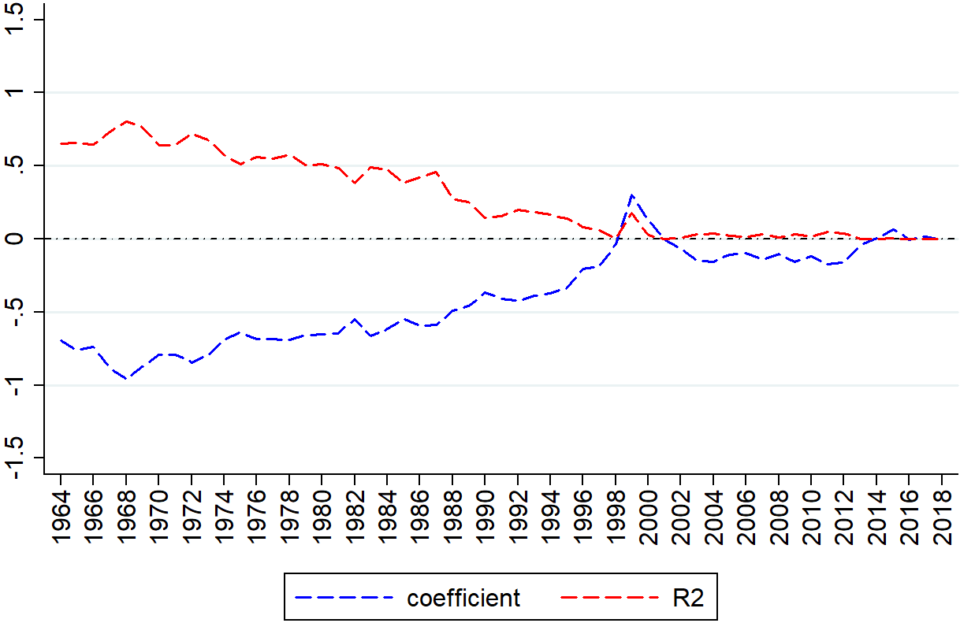

**Panel B The trend based on the primary sample with available analyst cash flows forecasts**

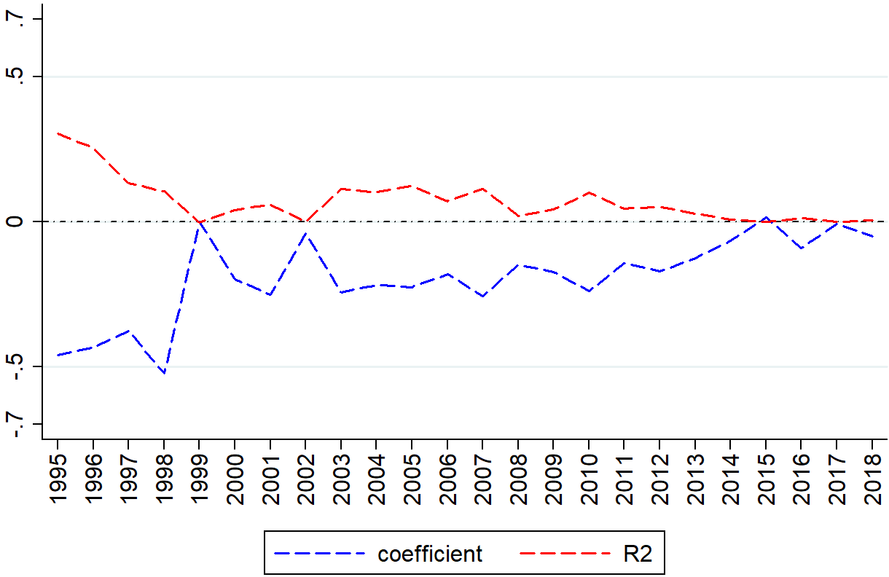

**Figure 2 The relationship between analysts’ forecasts of accruals and cash flows over time**

This figure represents results from Panel A of Table 6 that examines the relationship between analysts’ forecasts of accruals and cash flows. The sample period is between 1995 and 2018. The Red (Blue) line represents the coefficient estimates on analysts’ cash flows forecasts (adjusted *R2*) in the equation (3).

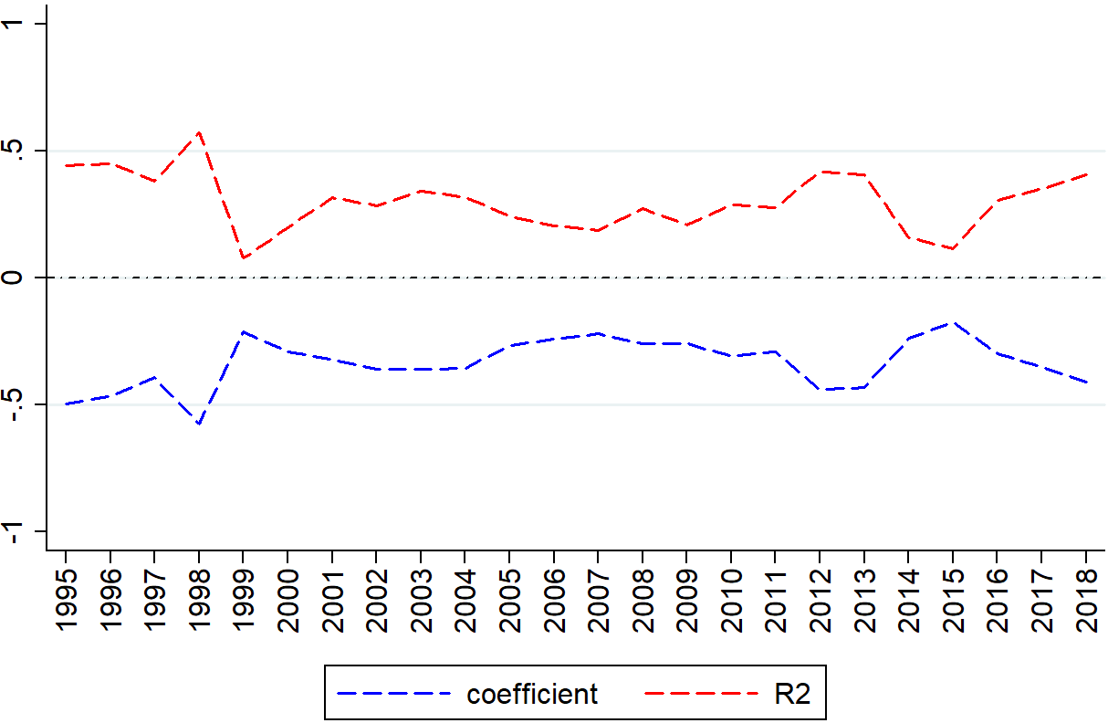

**Figure 3 The effects of current cash flows and accruals on future cash flows over time**

This figure illustrates estimation results from Panel B of Table 7 that examines whether reported current cash flows and accruals affect reported future cash flows using the primary sample (i.e., firm-year observations with available analysts’ cash flows forecasts from IBES). Panel A shows the trend of the coefficient estimates obtained from the equation (4). The red (blue) line represents coefficient estimates on current cash flows (accruals). Panel B shows the trend of the adjusted *R2* obtained from the equation (4). The green line represents the total adjusted *R2*, and the red (blue) line represents the incremental adjusted *R2* due to the additional inclusion of current cash flows (accruals) in the equation (4).

**Panel A The coefficients on current cash flows and current accruals from the equation (4)**

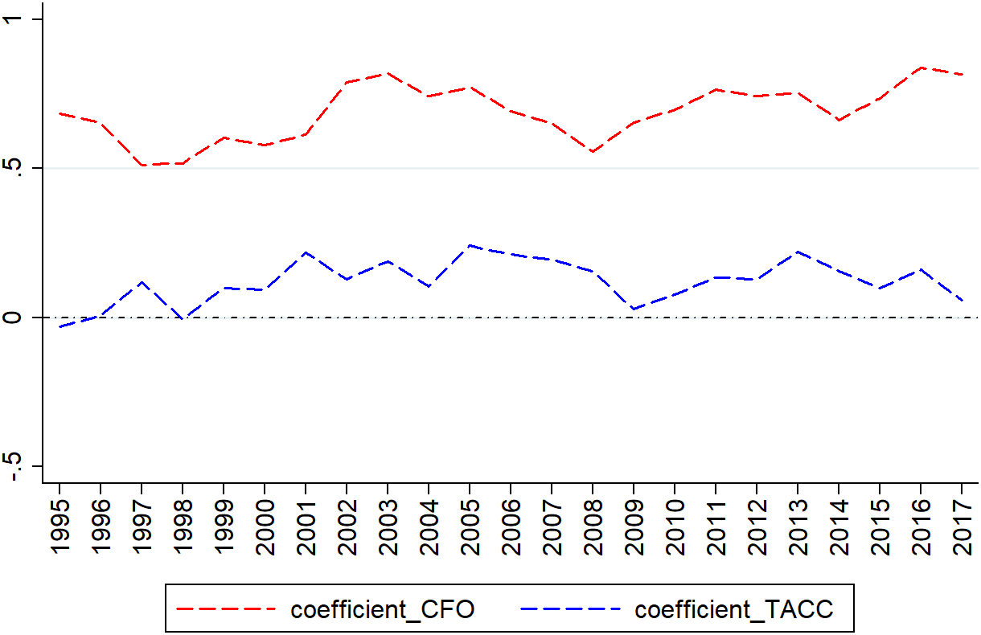

**Panel B The adjusted R2 from the equation (4)**

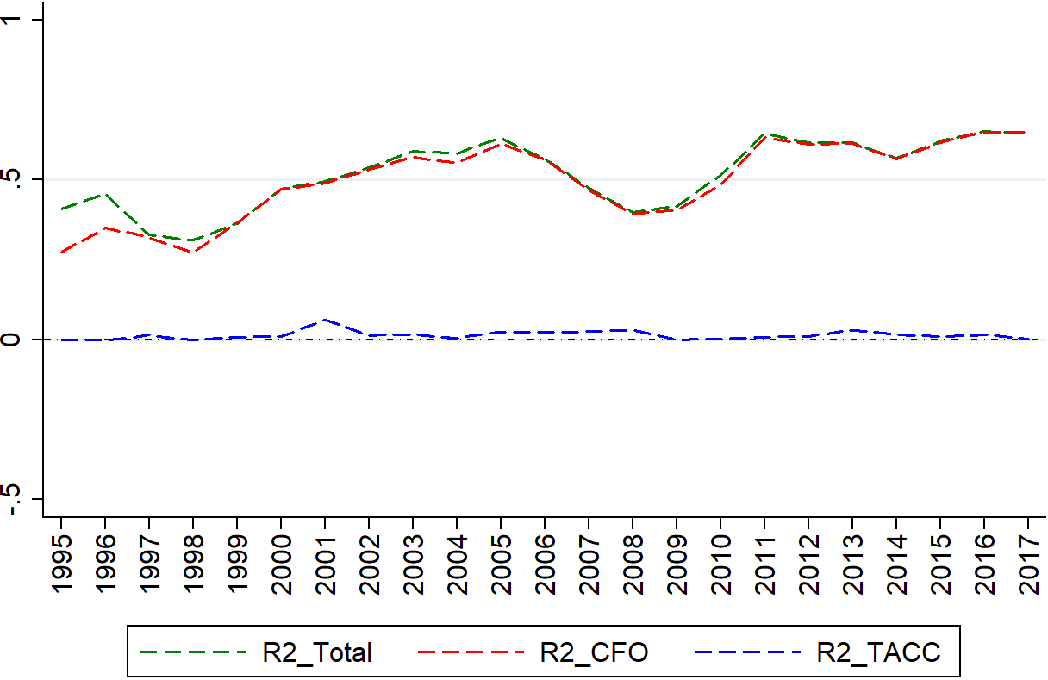

**Figure 4 The effects of analysts’ forecasts of cash flows and accruals on future cash flows**

This figure illustrates the estimation results in Panel A of Table 8 that examines the effects of analysts’ forecasts of cash flows and accruals on future reported cash flows. Panel A shows the trend of the coefficient estimates in the equation (5). The red (blue) line represents coefficients on the analysts’ forecasts of cash flows (accruals). Panel B shows the trend of the adjusted R2 from the equation (5). The green line represents the total adjusted R2 from the equation (5), and the red (blue) line represents the incremental adjusted R2 due to the additional inclusion of analyst forecasts of cash flows (accruals) in the equation (5).

**Panel A** **The coefficient estimates from the equation (5)**

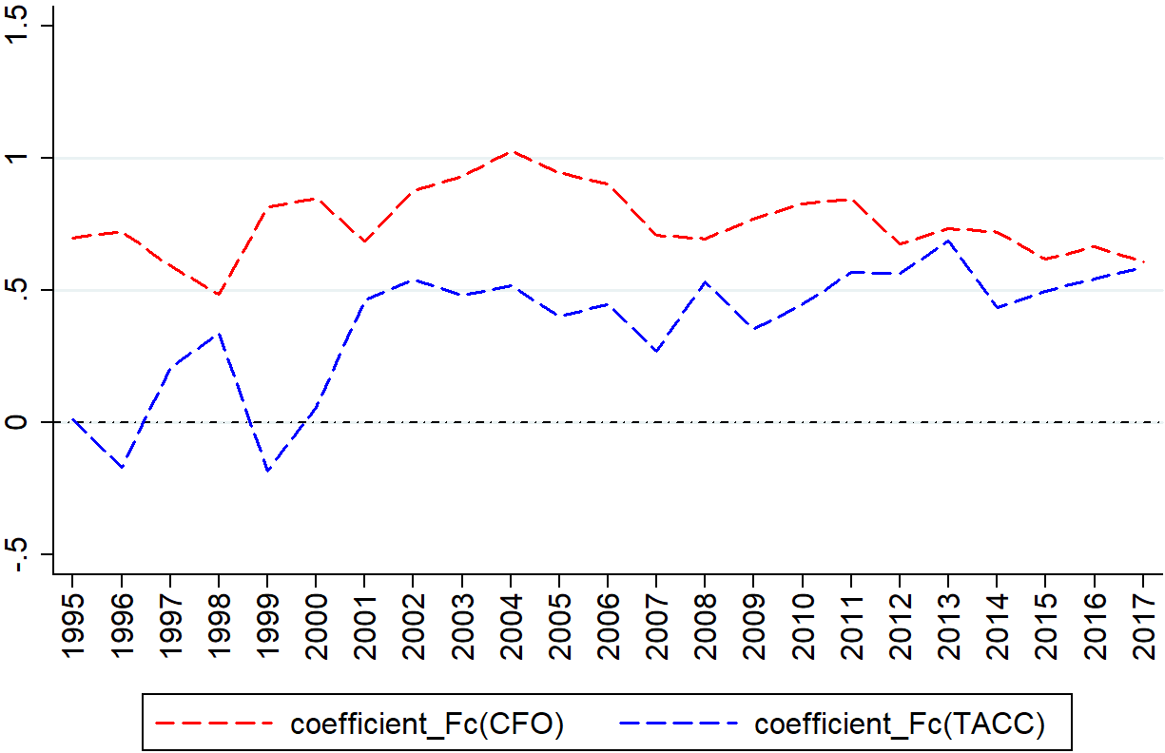

**Panel B The adjusted R2 from the equation (5)**

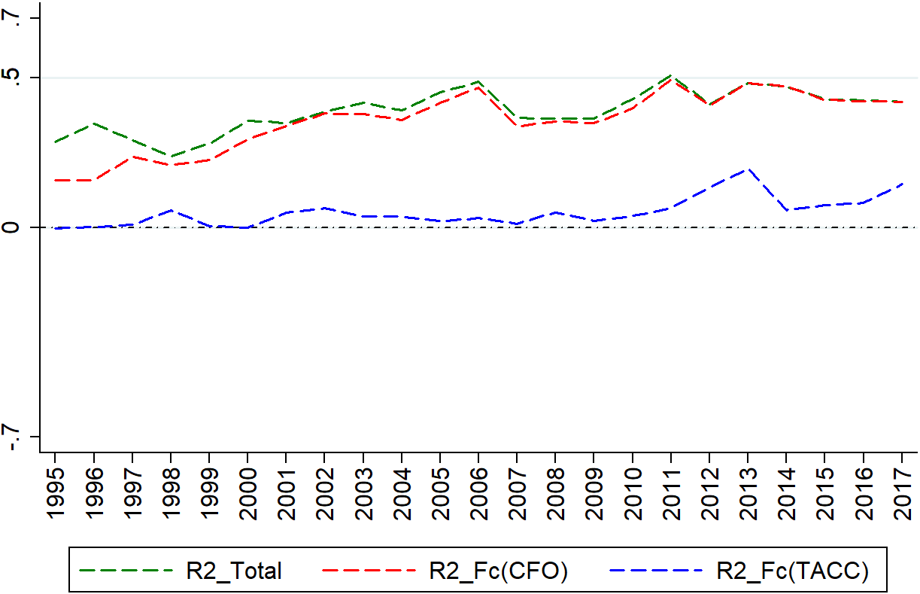

**Table 1 Sample selection**

This table describes the sample selection criteria. We start with a sample period of 1964 to 2018 to mirror Bushman et al. (2016). The sample period of the final sample with available analyst forecast data is between 1995 and 2018.

|  |  |
| --- | --- |
| **Criteria** | N |
| # of Firm-Year Obs. in COMPUSTAT between 1964 and 2018 | 492,167 |
| # of Firm-Year Obs. with positive total assets and sales greater than $5M | 344,868 |
| Excluding Firm-Year Obs. in financial industries [60<=SIC<= 69] | 296,704 |
| Excluding Firm-Year Obs. with significant acquisition activity  (Ratio of sales from mergers and acquisitions to net sales over 5%) | 279,530 |
| # of Firm-Year Obs. with non-missing realized earnings, accruals, and cash flows | **247,019** |
| # of Firm-Year Obs. in COMPUSTAT between 1995 and 2018 | 127,522 |
| The intersection of COMPUSTAT and IBES | 88,515 |
| # of Firm-Year Obs. with available consensus analyst EPS and CF forecasts | **33,851** |

**Table 2 Descriptive statistics**

This table presents the descriptive statistics for the main variables. To facilitate the comparison with Bushman et al. (2016), we provide the descriptive statistics for the period 1964 to 2014, which corresponds to the sample period in Bushman et al. (2016). We also reproduce Panel A of Table 1 in Bushman et al. (2016) and include the descriptive statistics in Panel C of this table. Panel D presents the descriptive statistics for the subsample of firm-year observations with available analyst cash flows forecasts and other control variables between 1995 and 2018. See Appendix A for the variable description. All continuous variables are winsorized at the top and bottom 1% level.

|  |  |  |  |  |  |  |
| --- | --- | --- | --- | --- | --- | --- |
| Variables | N | Mean | STD | Q1 | Median | Q3 |
| **Panel A Sample period: 1964 - 2018** | | | |  |  |  |
| *EARNt* | 247,019 | 0.010 | 0.214 | -0.006 | 0.042 | 0.087 |
| *TACCt* | 247,019 | -0.052 | 0.149 | -0.098 | -0.046 | 0.001 |
| *CFOt-1* | 229,592 | 0.056 | 0.196 | 0.014 | 0.077 | 0.136 |
| *CFOt* | 247,019 | 0.061 | 0.175 | 0.015 | 0.077 | 0.136 |
| *CFOt+1* | 226,108 | 0.066 | 0.145 | 0.017 | 0.078 | 0.136 |
| **Panel B Sample period: 1964 - 2014** | | | |  |  |  |
| *EARNt* | 230,226 | 0.013 | 0.211 | -0.003 | 0.043 | 0.088 |
| *TACCt* | 230,226 | -0.05 | 0.149 | -0.097 | -0.045 | 0.003 |
| *CFOt-1* | 213,406 | 0.057 | 0.195 | 0.014 | 0.077 | 0.136 |
| *CFOt* | 230,226 | 0.062 | 0.174 | 0.015 | 0.077 | 0.137 |
| *CFOt+1* | 214,376 | 0.067 | 0.144 | 0.017 | 0.078 | 0.136 |
| **Panel C Descriptive statistics in Panel A, Table 1 of Bushman et al. (2016)** | | | | | | |
| *EARNt* | 217,164 | −0.004 | 0.186 | −0.013 | 0.039 | 0.077 |
| *TACCt* | 217,164 | −0.054 | 0.129 | −0.093 | −0.045 | −0.001 |
| *CFOt-1* | 186,109 | 0.055 | 0.145 | 0.013 | 0.074 | 0.127 |
| *CFOt* | 217,164 | 0.050 | 0.153 | 0.008 | 0.072 | 0.127 |
| *CFOt+1* | 184,881 | 0.056 | 0.144 | 0.015 | 0.075 | 0.128 |
| **Panel D Primary sample: 1995 – 2018** | | | | | | |
| *EARNt* | 33,851 | 0.025 | 0.157 | 0.000 | 0.044 | 0.090 |
| *TACCt* | 33,851 | -0.075 | 0.104 | -0.105 | -0.059 | -0.028 |
| *CFOt-1* | 33,659 | 0.100 | 0.155 | 0.055 | 0.101 | 0.161 |
| *CFOt* | 33,851 | 0.100 | 0.133 | 0.054 | 0.099 | 0.156 |
| *CFOt+1* | 30,409 | 0.101 | 0.121 | 0.055 | 0.099 | 0.156 |

**Table 3 The relationship between accruals and cash flows over time**

This table presents the estimation results replicating Table 2 in Bushman et al. (2016). Panel A shows the replication results for the period between 1964 and 2018 in columns 1-3. In column 4 and 5, we reproduce the results in Table 2 in Bushman et al. (2016) for comparison. Panel B presents the results for the sample period between 1995 and 2018 using firm-year observations that require non-missing analyst cash flows and earnings forecasts. See Appendix A for the variable description. All continuous variables are winsorized at the top and bottom 1% level. *t*-statistics are adjusted for Newey-West autocorrelation up to three lags.

|  |  |  |  |  |  |
| --- | --- | --- | --- | --- | --- |
| **Panel A** *TACCt* = *β0* + *β1 CFOt* + *εt* | | | | | |
|  | Sample period: 1964 to 2018 | | | Table 2 of Bushman et al. (2016) | |
|  | *CFOt (β1)* | | *Adj. R2* | *CFOt (β1)* | *Adj. R2* |
| YEAR | (1) | (2) | (3) | (4) | (5) |
|  | Coeff | t-Stat |  | Coeff |  |
| 1964 | -0.695 | -56.000 | 0.653 | -0.68 | 0.66 |
| 1965 | -0.761 | -58.724 | 0.657 | -0.72 | 0.67 |
| 1966 | -0.738 | -60.116 | 0.646 | -0.71 | 0.65 |
| 1967 | -0.883 | -76.509 | 0.731 | -0.79 | 0.69 |
| 1968 | -0.959 | -98.703 | 0.804 | -0.81 | 0.74 |
| 1969 | -0.875 | -98.668 | 0.768 | -0.79 | 0.74 |
| 1970 | -0.795 | -74.372 | 0.640 | -0.74 | 0.60 |
| 1971 | -0.791 | -77.025 | 0.644 | -0.75 | 0.63 |
| 1972 | -0.844 | -94.366 | 0.723 | -0.79 | 0.69 |
| 1973 | -0.794 | -86.626 | 0.681 | -0.75 | 0.68 |
| 1974 | -0.690 | -71.952 | 0.575 | -0.70 | 0.59 |
| 1975 | -0.639 | -68.599 | 0.510 | -0.67 | 0.54 |
| 1976 | -0.687 | -75.962 | 0.561 | -0.67 | 0.54 |
| 1977 | -0.686 | -73.247 | 0.548 | -0.66 | 0.54 |
| 1978 | -0.692 | -76.891 | 0.574 | -0.66 | 0.54 |
| 1979 | -0.658 | -66.222 | 0.508 | -0.64 | 0.49 |
| 1980 | -0.653 | -66.266 | 0.510 | -0.67 | 0.53 |
| 1981 | -0.646 | -62.408 | 0.483 | -0.63 | 0.50 |
| 1982 | -0.549 | -50.533 | 0.382 | -0.56 | 0.40 |
| 1983 | -0.665 | -64.727 | 0.492 | -0.57 | 0.40 |
| 1984 | -0.617 | -62.597 | 0.474 | -0.48 | 0.33 |
| 1985 | -0.550 | -51.459 | 0.380 | -0.43 | 0.25 |
| 1986 | -0.591 | -56.507 | 0.421 | -0.44 | 0.28 |
| 1987 | -0.589 | -62.211 | 0.457 | -0.54 | 0.37 |
| 1988 | -0.490 | -39.834 | 0.274 | -0.48 | 0.25 |
| 1989 | -0.460 | -38.589 | 0.251 | -0.46 | 0.23 |
| 1990 | -0.365 | -27.554 | 0.144 | -0.36 | 0.12 |
| 1991 | -0.409 | -29.408 | 0.157 | -0.33 | 0.1 |
| 1992 | -0.424 | -34.366 | 0.199 | -0.31 | 0.11 |
| 1993 | -0.390 | -34.054 | 0.186 | -0.29 | 0.09 |
| 1994 | -0.370 | -32.022 | 0.165 | -0.28 | 0.10 |
| 1995 | -0.335 | -30.067 | 0.139 | -0.24 | 0.07 |
| 1996 | -0.207 | -23.509 | 0.082 | -0.18 | 0.06 |
| 1997 | -0.188 | -19.420 | 0.057 | -0.11 | 0.02 |
| 1998 | -0.039 | -4.069 | 0.003 | -0.05 | 0.00 |
| 1999 | 0.300 | 37.271 | 0.175 | 0.03 | 0.00 |
| 2000 | 0.130 | 12.956 | 0.025 | 0.09 | 0.01 |
| 2001 | -0.007 | -0.563 | 0.000 | 0.09 | 0.01 |
| 2002 | -0.070 | -5.907 | 0.006 | 0.04 | 0.00 |
| 2003 | -0.150 | -13.878 | 0.032 | -0.08 | 0.01 |
| 2004 | -0.155 | -14.763 | 0.037 | -0.07 | 0.01 |
| 2005 | -0.105 | -10.707 | 0.020 | -0.05 | 0.00 |
| 2006 | -0.099 | -9.319 | 0.016 | -0.02 | 0.00 |
| 2007 | -0.141 | -13.307 | 0.032 | -0.02 | 0.00 |
| 2008 | -0.102 | -8.021 | 0.012 | 0.02 | 0.00 |
| 2009 | -0.155 | -12.734 | 0.030 | -0.08 | 0.01 |
| 2010 | -0.121 | -9.109 | 0.016 | -0.03 | 0.00 |
| 2011 | -0.174 | -15.179 | 0.046 | -0.05 | 0.01 |
| 2012 | -0.162 | -14.045 | 0.040 | -0.02 | 0.00 |
| 2013 | -0.041 | -3.282 | 0.002 | 0.06 | 0.00 |
| 2014 | 0.004 | 0.325 | 0.000 | 0.01 | 0.00 |
| 2015 | 0.065 | 5.013 | 0.005 | - | - |
| 2016 | -0.004 | -0.321 | 0.000 | - | - |
| 2017 | 0.017 | 1.451 | 0.000 | - | - |
| 2018 | -0.003 | -0.255 | 0.000 | - | - |
| Average | -0.395 | -37.781 | 0.290 | -0.37 | 0.28 |
| **Time Trend** | **0.018** |  | **-0.016** | **0.020** | **-0.018** |
| **t-Statistics** | **13.370** |  | **-13.270** | **13.070** | **-12.460** |

**Table 3 -** *Continued*

|  |  |  |  |
| --- | --- | --- | --- |
| **Panel B** *TACCt* = *β0* + *β1 CFOt* + *εt* | | | |
|  | *CFOt (β1)* | | *Adj. R2* |
| YEAR | (1) | (2) | (3) |
|  | Coeff | t-Stat |  |
| 1995 | -0.460 | -11.475 | 0.304 |
| 1996 | -0.435 | -10.436 | 0.255 |
| 1997 | -0.376 | -7.456 | 0.134 |
| 1998 | -0.524 | -6.857 | 0.105 |
| 1999 | -0.001 | -0.035 | -0.001 |
| 2000 | -0.198 | -6.248 | 0.041 |
| 2001 | -0.252 | -7.207 | 0.059 |
| 2002 | -0.041 | -1.426 | 0.001 |
| 2003 | -0.243 | -14.241 | 0.112 |
| 2004 | -0.219 | -13.676 | 0.102 |
| 2005 | -0.226 | -15.994 | 0.124 |
| 2006 | -0.181 | -11.823 | 0.071 |
| 2007 | -0.256 | -15.082 | 0.113 |
| 2008 | -0.149 | -6.225 | 0.020 |
| 2009 | -0.172 | -9.086 | 0.043 |
| 2010 | -0.239 | -14.182 | 0.100 |
| 2011 | -0.142 | -9.270 | 0.045 |
| 2012 | -0.171 | -10.100 | 0.052 |
| 2013 | -0.126 | -7.234 | 0.027 |
| 2014 | -0.066 | -4.182 | 0.008 |
| 2015 | 0.014 | 0.695 | 0.000 |
| 2016 | -0.091 | -4.963 | 0.012 |
| 2017 | -0.007 | -0.424 | 0.000 |
| 2018 | -0.049 | -3.377 | 0.006 |
| Average | -0.192 | -7.929 | 0.072 |
| **Time Trend** | **0.014** |  | **-0.007** |
| **t-Statistics** | **4.230** |  | **-2.540** |

**Table 4 Analyst forecast of cash flows as a function of reported cash flows and accruals**

This table reports the estimation results examining the use of reported accruals and cash flows in forming analyst cash flows forecasts. The sample period is between 1995 and 2018. See Appendix A for the variable description. All continuous variables are winsorized at the top and bottom 1% level. *t*-statistics are adjusted for Newey-West autocorrelation up to three lags.

|  |  |  |  |  |  |  |  |
| --- | --- | --- | --- | --- | --- | --- | --- |
|  | *Fc(CFOt)* = *β0* + *β1 CFOt-1* + β2 *TACCt-1*+ *εt-1* | | | | | | |
|  | *CFOi.t-1 (β1)* | | *TACCt-1 (β2)* | | *Adj. R2* | | |
| YEAR | (1) | (2) | (3) | (4) | (5) | (6) | (7) |
|  | Coeff | t-Stat | Coeff | t-Stat | Total | INC CFO | INC ACC |
| 1995 | 0.442 | 10.683 | 0.019 | 0.362 | 0.314 | 0.268 | -0.002 |
| 1996 | 0.576 | 14.243 | 0.182 | 4.406 | 0.401 | 0.395 | 0.036 |
| 1997 | 0.618 | 19.786 | 0.277 | 7.893 | 0.538 | 0.541 | 0.085 |
| 1998 | 0.533 | 10.429 | 0.187 | 3.996 | 0.216 | 0.218 | 0.030 |
| 1999 | 0.291 | 19.207 | 0.048 | 3.086 | 0.332 | 0.330 | 0.008 |
| 2000 | 0.125 | 13.049 | -0.006 | -0.489 | 0.176 | 0.159 | -0.001 |
| 2001 | 0.421 | 22.791 | 0.078 | 5.112 | 0.392 | 0.393 | 0.019 |
| 2002 | 0.480 | 26.691 | 0.118 | 6.877 | 0.372 | 0.368 | 0.024 |
| 2003 | 0.539 | 33.246 | 0.124 | 6.828 | 0.410 | 0.410 | 0.017 |
| 2004 | 0.400 | 32.117 | 0.068 | 4.096 | 0.388 | 0.386 | 0.006 |
| 2005 | 0.422 | 37.046 | 0.050 | 3.348 | 0.435 | 0.434 | 0.003 |
| 2006 | 0.498 | 41.987 | 0.117 | 7.603 | 0.497 | 0.493 | 0.016 |
| 2007 | 0.422 | 34.911 | 0.196 | 11.222 | 0.409 | 0.410 | 0.042 |
| 2008 | 0.487 | 34.832 | 0.150 | 9.737 | 0.401 | 0.402 | 0.031 |
| 2009 | 0.491 | 37.211 | 0.122 | 9.249 | 0.434 | 0.432 | 0.026 |
| 2010 | 0.580 | 38.516 | 0.072 | 3.702 | 0.461 | 0.445 | 0.004 |
| 2011 | 0.453 | 30.009 | 0.051 | 2.462 | 0.335 | 0.333 | 0.002 |
| 2012 | 0.632 | 29.548 | 0.138 | 4.339 | 0.324 | 0.321 | 0.007 |
| 2013 | 0.625 | 30.606 | 0.101 | 3.568 | 0.341 | 0.340 | 0.004 |
| 2014 | 0.446 | 35.593 | 0.013 | 0.791 | 0.397 | 0.395 | 0.000 |
| 2015 | 0.488 | 32.773 | 0.101 | 5.401 | 0.371 | 0.346 | 0.009 |
| 2016 | 0.627 | 30.407 | 0.161 | 7.147 | 0.342 | 0.325 | 0.018 |
| 2017 | 0.663 | 24.733 | 0.208 | 6.249 | 0.265 | 0.251 | 0.016 |
| 2018 | 0.708 | 29.363 | -0.131 | -3.568 | 0.340 | 0.338 | 0.005 |
| Average | 0.499 | 27.907 | 0.102 | 4.726 | 0.370 | 0.364 | 0.017 |
| **Time Trend** | **0.008** |  | **-0.002** |  | **0.000** | **0.000** | **-0.001** |
| **t-Statistics** | **1.87** |  | **-1.060** |  | **-0.170** | **-0.150** | **-1.900** |

**Table 5 Correcting for self-selection**

We follow the analysis described in DeFond and Hung (2003) to correct for the selection issue that arises from the analysts’ cash flows forecasts. Panel A presents the descriptive statistics for the variables employed by DeFond and Hung (2003) in their first stage Heckman correction model.Panel B describes the first-stage regression results. Panel C presents the estimation results that examine the usefulness of reported cash flows and accruals for analysts in their formation of cash flow forecasts after including the inverse mills ratio (IMR). The sample period is between 1995 and 2018. See Appendix A for the variable description. All continuous variables are winsorized at the top and bottom 1% level. *t*-statistics are adjusted for Newey-West autocorrelation up to three lags.

|  |  |  |  |  |  |  |
| --- | --- | --- | --- | --- | --- | --- |
| **Panel A Summary statistics of main variables used in the first stage analysis** | | | | | | |
| Variables | N | Mean | STD | Q1 | Median | Q3 |
| *BOTH_EPS_CFt* | 67,313 | 0.476 | 0.499 | 0.000 | 0.000 | 1.000 |
| *ABS_ACCt-1 (%)* | 67,313 | 8.918 | 10.630 | 3.119 | 5.995 | 10.700 |
| *ACT_CHOICEt-1* | 67,313 | 0.263 | 0.206 | 0.000 | 0.250 | 0.500 |
| *EPS_VOLt-1* | 67,313 | 4.344 | 10.570 | 0.630 | 1.489 | 3.459 |
| *CAPt-1* | 67,313 | 1.010 | 1.583 | 0.229 | 0.437 | 0.984 |
| *Z-SCOREt-1* | 67,313 | 4.689 | 7.244 | 1.650 | 3.106 | 5.436 |
| *SIZEt-1* | 67,313 | 6.518 | 1.968 | 5.066 | 6.390 | 7.827 |

**Table 5 –** *Continued*

|  |  |  |  |  |  |  |  |  |  |  |  |  |  |
| --- | --- | --- | --- | --- | --- | --- | --- | --- | --- | --- | --- | --- | --- |
| **Panel B First stage regression results** | | | | | | | | | | | | | |
|  | *BOTH_EPS_CFt* = *β0 + β1 ABS_ACCt-1 + β2 ACT_CHOICEt-1+ β3 EPS_VOLt-1 + β4 CAPt-1 + β5 Z-SCOREt-1 + β6 SIZEt-1*+ *εt* | | | | | | | | | | | | |
|  | *ABS_ACCt-1 (β1)* | | *ACT_CHOICEt-1* *(β2)* | | *EPS_VOLt-1* *(β3)* | | *CAPi.t-1 (β4)* | | *Z-SCOREt-1 (β5)* | | *SIZEt-1 (β6)* | | Pseudo R2 |
| YEAR | (1) | (2) | (3) | (4) | (5) | (6) | (7) | (8) | (9) | (10) | (11) | (12) | (13) |
|  | Coeff | t-Stat | Coeff | t-Stat | Coeff | t-Stat | Coeff | t-Stat | Coeff | t-Stat | Coeff | t-Stat |  |
| 1995 | 0.201 | 0.354 | 0.487 | 2.656 | 0.010 | 3.079 | 0.327 | 12.272 | -0.039 | -3.375 | 0.269 | 12.769 | 0.234 |
| 1996 | 1.228 | 1.251 | 1.268 | 3.576 | 0.014 | 2.516 | 0.627 | 14.319 | -0.079 | -4.230 | 0.467 | 12.382 | 0.252 |
| 1997 | 0.680 | 0.702 | 0.067 | 0.198 | 0.015 | 2.748 | 0.587 | 13.850 | -0.101 | -4.955 | 0.456 | 12.481 | 0.250 |
| 1998 | 1.401 | 1.933 | 0.601 | 1.923 | 0.013 | 2.691 | 0.612 | 15.159 | -0.042 | -3.162 | 0.491 | 14.199 | 0.243 |
| 1999 | 0.907 | 1.640 | 0.302 | 1.204 | 0.001 | 0.219 | 0.491 | 12.851 | -0.059 | -5.518 | 0.699 | 22.316 | 0.292 |
| 2000 | -1.909 | -2.521 | 0.588 | 2.476 | -0.001 | -0.247 | 0.486 | 14.351 | -0.033 | -7.491 | 0.678 | 22.524 | 0.291 |
| 2001 | -0.674 | -1.213 | 0.531 | 2.223 | 0.003 | 0.626 | 0.409 | 10.331 | -0.067 | -8.123 | 0.661 | 22.136 | 0.270 |
| 2002 | -0.314 | -1.328 | 0.119 | 0.538 | 0.007 | 1.854 | 0.327 | 8.127 | -0.030 | -4.365 | 0.770 | 23.791 | 0.257 |
| 2003 | 0.221 | 0.568 | 0.003 | 0.013 | 0.001 | 0.254 | 0.336 | 7.770 | -0.050 | -4.475 | 1.103 | 25.578 | 0.361 |
| 2004 | 0.604 | 1.039 | 0.110 | 0.452 | 0.006 | 1.383 | 0.343 | 7.354 | -0.019 | -2.391 | 1.203 | 25.247 | 0.371 |
| 2005 | -0.298 | -0.455 | -0.108 | -0.462 | 0.009 | 2.013 | 0.265 | 5.868 | -0.015 | -2.046 | 1.095 | 24.796 | 0.325 |
| 2006 | 0.505 | 0.812 | -0.343 | -1.450 | 0.015 | 2.959 | 0.321 | 6.830 | 0.005 | 0.575 | 1.013 | 23.947 | 0.303 |
| 2007 | 0.295 | 0.556 | -0.279 | -1.153 | 0.007 | 1.421 | 0.256 | 6.526 | -0.004 | -0.450 | 1.065 | 24.170 | 0.321 |
| 2008 | 0.561 | 0.963 | -0.186 | -0.771 | 0.004 | 0.802 | 0.251 | 6.768 | -0.004 | -0.549 | 1.052 | 24.310 | 0.317 |
| 2009 | 0.981 | 3.147 | -0.347 | -1.452 | 0.010 | 2.192 | 0.237 | 6.188 | -0.022 | -1.700 | 0.981 | 24.834 | 0.313 |
| 2010 | 0.915 | 1.992 | -0.194 | -0.749 | 0.013 | 2.668 | 0.247 | 7.219 | -0.002 | -0.187 | 1.137 | 24.243 | 0.359 |
| 2011 | 0.563 | 0.933 | 0.043 | 0.164 | 0.006 | 1.187 | 0.253 | 7.133 | -0.013 | -1.174 | 1.110 | 23.445 | 0.352 |
| 2012 | 1.878 | 2.655 | -0.444 | -1.664 | 0.004 | 0.848 | 0.256 | 7.209 | -0.012 | -1.056 | 1.038 | 23.215 | 0.337 |
| 2013 | 2.103 | 3.397 | 0.207 | 0.785 | -0.001 | -0.285 | 0.328 | 8.328 | -0.013 | -1.148 | 0.945 | 22.447 | 0.318 |
| 2014 | 2.730 | 3.801 | 0.034 | 0.124 | -0.001 | -0.127 | 0.258 | 7.342 | 0.003 | 0.340 | 1.016 | 22.410 | 0.319 |
| 2015 | 2.491 | 3.920 | -0.518 | -1.948 | 0.002 | 0.393 | 0.266 | 7.229 | 0.000 | 0.037 | 0.887 | 21.199 | 0.274 |
| 2016 | 2.407 | 5.029 | -0.259 | -0.984 | -0.007 | -1.460 | 0.261 | 7.481 | 0.007 | 0.630 | 0.797 | 20.367 | 0.261 |
| 2017 | 1.368 | 2.895 | -0.476 | -1.731 | 0.002 | 0.382 | 0.183 | 7.116 | 0.004 | 0.318 | 0.836 | 20.642 | 0.275 |
| 2018 | 0.931 | 1.317 | -0.526 | -1.731 | 0.007 | 1.128 | 0.240 | 6.958 | -0.025 | -2.350 | 0.881 | 19.741 | 0.287 |
| Average [1995-1999] | 0.884 | 1.176 | 0.545 | 1.911 | 0.011 | 2.251 | 0.529 | 13.690 | -0.064 | -4.248 | 0.476 | 14.830 | 0.254 |
| Average [1995-2018] | 0.824 | 1.391 | 0.028 | 0.093 | 0.006 | 1.218 | 0.340 | 8.941 | -0.025 | -2.369 | 0.860 | 21.383 | 0.299 |

**Table 5 –** *Continued*

|  |  |  |  |  |  |  |  |
| --- | --- | --- | --- | --- | --- | --- | --- |
| **Panel C The effects of reported cash flows and accruals on analyst cash flows forecasts** | | | | | | | |
|  | *Fc(CFOt)* = *β0* + *β1 CFOt-1* + *β2 TACCt-1* + *β3 IMR* + *εt* | | | | | | |
|  | *CFOt-1 (β1)* | | *TACCt-1 (β2)* | | *Adj. R2* | | |
| YEAR | (1) | (2) | (3) | (4) | (5) | (6) | (7) |
|  | Coeff | t-Stat | Coeff | t-Stat | Total | INC CFO | INC ACC |
| 1995 | 0.434 | 9.847 | -0.005 | -0.080 | 0.304 | 0.243 | -0.003 |
| 1996 | 0.576 | 13.961 | 0.176 | 3.986 | 0.397 | 0.396 | 0.030 |
| 1997 | 0.616 | 19.484 | 0.278 | 7.663 | 0.539 | 0.545 | 0.083 |
| 1998 | 0.535 | 10.952 | 0.194 | 4.152 | 0.238 | 0.242 | 0.033 |
| 1999 | 0.388 | 20.798 | 0.104 | 6.215 | 0.376 | 0.377 | 0.033 |
| 2000 | 0.146 | 13.544 | 0.016 | 1.064 | 0.185 | 0.177 | 0.000 |
| 2001 | 0.431 | 23.623 | 0.064 | 4.263 | 0.416 | 0.418 | 0.013 |
| 2002 | 0.502 | 26.421 | 0.131 | 7.347 | 0.376 | 0.370 | 0.028 |
| 2003 | 0.567 | 33.249 | 0.125 | 6.760 | 0.434 | 0.406 | 0.016 |
| 2004 | 0.439 | 31.880 | 0.068 | 3.880 | 0.413 | 0.382 | 0.005 |
| 2005 | 0.422 | 34.608 | 0.050 | 3.124 | 0.428 | 0.401 | 0.003 |
| 2006 | 0.528 | 43.493 | 0.144 | 9.033 | 0.562 | 0.483 | 0.021 |
| 2007 | 0.467 | 35.556 | 0.196 | 11.148 | 0.455 | 0.413 | 0.040 |
| 2008 | 0.501 | 33.975 | 0.174 | 10.862 | 0.427 | 0.381 | 0.039 |
| 2009 | 0.508 | 36.152 | 0.138 | 10.206 | 0.447 | 0.412 | 0.033 |
| 2010 | 0.590 | 38.314 | 0.057 | 2.953 | 0.486 | 0.444 | 0.002 |
| 2011 | 0.459 | 29.056 | 0.060 | 2.906 | 0.352 | 0.319 | 0.003 |
| 2012 | 0.656 | 28.407 | 0.109 | 3.274 | 0.334 | 0.308 | 0.004 |
| 2013 | 0.665 | 30.653 | 0.092 | 3.255 | 0.362 | 0.348 | 0.004 |
| 2014 | 0.475 | 36.167 | 0.091 | 5.655 | 0.457 | 0.395 | 0.009 |
| 2015 | 0.527 | 32.997 | 0.085 | 4.353 | 0.403 | 0.357 | 0.006 |
| 2016 | 0.677 | 29.430 | 0.180 | 7.355 | 0.345 | 0.322 | 0.020 |
| 2017 | 0.686 | 23.835 | 0.153 | 4.439 | 0.275 | 0.244 | 0.008 |
| 2018 | 0.657 | 23.143 | 0.025 | 0.546 | 0.281 | 0.252 | 0.000 |
| Average | 0.519 | 27.481 | 0.113 | 5.182 | 0.387 | 0.360 | 0.018 |
| **Time Trend** | **0.008** |  | **-0.001** |  | **-0.001** | **-0.002** | **-0.001** |
| **t-Statistics** | **2.25** |  | **-0.580** |  | **-0.190** | **-0.750** | **-2.260** |

**Table 6 The relationship between analyst forecasts of accruals and cash flows**

This table presents estimation results that show the association between analysts’ forecasts of cash flows and accruals. Panel A presents the main results. Panel B presents the results from the regression including the inverse mills ratio (IMR). The sample period is between 1995 and 2018. See Appendix A for the variable description. All continuous variables are winsorized at the top and bottom 1% level. *t*-statistics are adjusted for Newey-West autocorrelation up to three lags.

|  |  |  |  |
| --- | --- | --- | --- |
| **Panel A** *Fc(TACCt) = β0 + β1 Fc(CFOt) + εt* | | | |
|  | *Fc(CFOt) (β1)* | | *Adj. R2* |
| YEAR | (1) | (2) | (3) |
|  | Coeff | t-Stat |  |
| 1995 | -0.495 | -15.440 | 0.443 |
| 1996 | -0.467 | -16.109 | 0.451 |
| 1997 | -0.393 | -14.789 | 0.381 |
| 1998 | -0.573 | -22.855 | 0.571 |
| 1999 | -0.213 | -8.054 | 0.077 |
| 2000 | -0.290 | -14.797 | 0.198 |
| 2001 | -0.322 | -19.315 | 0.316 |
| 2002 | -0.359 | -22.103 | 0.285 |
| 2003 | -0.361 | -28.826 | 0.342 |
| 2004 | -0.355 | -27.619 | 0.317 |
| 2005 | -0.267 | -24.006 | 0.242 |
| 2006 | -0.239 | -21.618 | 0.205 |
| 2007 | -0.221 | -20.178 | 0.187 |
| 2008 | -0.258 | -25.996 | 0.272 |
| 2009 | -0.258 | -21.960 | 0.209 |
| 2010 | -0.308 | -26.966 | 0.287 |
| 2011 | -0.291 | -26.402 | 0.277 |
| 2012 | -0.440 | -36.497 | 0.419 |
| 2013 | -0.432 | -35.198 | 0.405 |
| 2014 | -0.238 | -19.200 | 0.159 |
| 2015 | -0.174 | -16.022 | 0.116 |
| 2016 | -0.298 | -28.753 | 0.306 |
| 2017 | -0.350 | -31.089 | 0.350 |
| 2018 | -0.409 | -33.906 | 0.404 |
| Average | -0.334 | -23.237 | 0.301 |
| **Time Trend** | **0.005** |  | **-0.004** |
| **t-Statistics** | **1.490** |  | **-0.880** |

**Table 6** **–** *Continued*

|  |  |  |  |
| --- | --- | --- | --- |
| **Panel B** *Fc(TACCt)* = *β0* + *β1 Fc(CFOt)* + *β3 IMR* + *εt* | | | |
|  | *Fc(CFOt) (β1)* | | *Adj. R2* |
| YEAR | (1) | (2) | (3) |
|  | Coeff | t-Stat |  |
| 1995 | -0.522 | -16.736 | 0.523 |
| 1996 | -0.456 | -15.852 | 0.484 |
| 1997 | -0.390 | -14.506 | 0.415 |
| 1998 | -0.556 | -21.357 | 0.561 |
| 1999 | -0.223 | -7.996 | 0.094 |
| 2000 | -0.288 | -14.211 | 0.199 |
| 2001 | -0.312 | -18.260 | 0.298 |
| 2002 | -0.367 | -22.067 | 0.293 |
| 2003 | -0.370 | -29.231 | 0.356 |
| 2004 | -0.354 | -26.513 | 0.310 |
| 2005 | -0.298 | -26.107 | 0.284 |
| 2006 | -0.270 | -23.216 | 0.238 |
| 2007 | -0.238 | -20.339 | 0.198 |
| 2008 | -0.277 | -27.051 | 0.295 |
| 2009 | -0.281 | -23.560 | 0.256 |
| 2010 | -0.322 | -28.347 | 0.323 |
| 2011 | -0.304 | -27.028 | 0.302 |
| 2012 | -0.471 | -41.234 | 0.497 |
| 2013 | -0.473 | -39.288 | 0.480 |
| 2014 | -0.311 | -26.117 | 0.275 |
| 2015 | -0.233 | -21.227 | 0.206 |
| 2016 | -0.310 | -29.867 | 0.341 |
| 2017 | -0.363 | -32.029 | 0.378 |
| 2018 | -0.460 | -36.673 | 0.473 |
| Average | -0.352 | -24.534 | 0.337 |
| **Time Trend** | **0.003** |  | **-0.001** |
| **t-Statistics** | **0.820** |  | **-0.250** |

**Table 7 The effects of cash flows and accruals on the future cash flows**

This table presents the estimation results that show the effects of cash flows and accruals on the future cash flows. In Panel A, the sample consists of all firm-year observations with reported cash flows and accruals. In Panel B, the sample consists of firm-year observations with reported cash flows and accruals and available analysts’ forecasts of cash flows and accruals (i.e., the primary sample). The sample period is between 1995 and 2018. Panel C reports the results using the primary sample and including IMR. See Appendix A for the variable description. All continuous variables are winsorized at the top and bottom 1% level. *t*-statistics are adjusted for Newey-West autocorrelation up to three lags.

|  |  |  |  |  |  |  |  |
| --- | --- | --- | --- | --- | --- | --- | --- |
| **Panel A All COMPUSTAT firms** | | | | | | | |
|  | *CFOt+1*= *β0* + *β1 CFOt* + *β2 TACCt* + *εt* | | | | | | |
|  | *CFOt (β1)* | | *TACCt (β2)* | | *Adj. R2* | | |
| YEAR | (1) | (2) | (3) | (4) | (5) | (6) | (7) |
|  | Coeff | t-Stat | Coeff | t-Stat | Total | Inc CFO | Inc ACC |
| 1995 | 0.571 | 49.608 | 0.203 | 15.722 | 0.322 | 0.320 | 0.032 |
| 1996 | 0.448 | 54.765 | 0.124 | 10.871 | 0.347 | 0.344 | 0.013 |
| 1997 | 0.511 | 57.502 | 0.142 | 12.532 | 0.369 | 0.369 | 0.017 |
| 1998 | 0.571 | 60.518 | 0.164 | 12.739 | 0.414 | 0.404 | 0.018 |
| 1999 | 0.331 | 49.565 | 0.001 | 0.149 | 0.334 | 0.283 | 0.000 |
| 2000 | 0.372 | 57.702 | 0.064 | 8.135 | 0.386 | 0.357 | 0.007 |
| 2001 | 0.592 | 65.271 | 0.143 | 14.995 | 0.439 | 0.422 | 0.022 |
| 2002 | 0.685 | 66.008 | 0.185 | 16.072 | 0.449 | 0.439 | 0.026 |
| 2003 | 0.716 | 68.288 | 0.159 | 12.593 | 0.467 | 0.467 | 0.016 |
| 2004 | 0.610 | 63.716 | 0.195 | 16.118 | 0.445 | 0.444 | 0.028 |
| 2005 | 0.649 | 69.537 | 0.163 | 12.739 | 0.492 | 0.492 | 0.016 |
| 2006 | 0.566 | 59.865 | 0.189 | 15.502 | 0.428 | 0.421 | 0.028 |
| 2007 | 0.569 | 56.567 | 0.188 | 14.504 | 0.401 | 0.400 | 0.026 |
| 2008 | 0.523 | 54.186 | 0.172 | 16.189 | 0.386 | 0.376 | 0.033 |
| 2009 | 0.666 | 57.409 | 0.181 | 13.717 | 0.409 | 0.409 | 0.023 |
| 2010 | 0.611 | 54.891 | 0.159 | 13.274 | 0.401 | 0.398 | 0.023 |
| 2011 | 0.684 | 66.967 | 0.176 | 13.554 | 0.506 | 0.506 | 0.021 |
| 2012 | 0.730 | 69.031 | 0.201 | 15.028 | 0.520 | 0.521 | 0.025 |
| 2013 | 0.688 | 72.640 | 0.166 | 14.932 | 0.547 | 0.533 | 0.022 |
| 2014 | 0.590 | 66.808 | 0.177 | 15.364 | 0.523 | 0.495 | 0.026 |
| 2015 | 0.651 | 67.121 | 0.142 | 12.609 | 0.533 | 0.506 | 0.018 |
| 2016 | 0.701 | 66.922 | 0.191 | 14.478 | 0.531 | 0.514 | 0.024 |
| 2017 | 0.762 | 73.256 | 0.166 | 11.344 | 0.612 | 0.598 | 0.014 |
| Average | 0.600 | 62.093 | 0.159 | 13.181 | 0.446 | 0.436 | 0.021 |
| **Time Trend** | **0.010** |  | **0.002** |  | **0.009** | **0.009** | **0.000** |
| **t-Statistics** | **4.520** |  | **1.550** |  | **8.620** | **9.520** | **0.950** |

**Table 7 –** *Continued*

|  |  |  |  |  |  |  |  |
| --- | --- | --- | --- | --- | --- | --- | --- |
| **Panel B Results using the primary sample** | | | | | | | |
|  | *CFOt+1*= *β0* + *β1 CFOt* + *β2 TACCt* + *εt* | | | | | | |
|  | *CFOt (β1)* | | *TACCt (β2)* | | *Adj. R2* | | |
| YEAR | (1) | (2) | (3) | (4) | (5) | (6) | (7) |
|  | Coeff | t-Stat | Coeff | t-Stat | Total | Inc CFO | Inc ACC |
| 1995 | 0.683 | 11.494 | -0.030 | -0.420 | 0.410 | 0.273 | -0.002 |
| 1996 | 0.654 | 13.815 | 0.007 | 0.131 | 0.455 | 0.349 | -0.002 |
| 1997 | 0.511 | 12.422 | 0.119 | 2.825 | 0.327 | 0.320 | 0.015 |
| 1998 | 0.518 | 11.895 | -0.005 | -0.188 | 0.311 | 0.273 | -0.002 |
| 1999 | 0.603 | 20.021 | 0.099 | 3.199 | 0.364 | 0.366 | 0.008 |
| 2000 | 0.578 | 27.256 | 0.093 | 4.148 | 0.471 | 0.470 | 0.010 |
| 2001 | 0.613 | 27.481 | 0.218 | 9.848 | 0.495 | 0.489 | 0.062 |
| 2002 | 0.790 | 37.158 | 0.129 | 5.961 | 0.538 | 0.533 | 0.013 |
| 2003 | 0.818 | 46.235 | 0.189 | 7.845 | 0.590 | 0.571 | 0.016 |
| 2004 | 0.742 | 45.386 | 0.104 | 4.402 | 0.583 | 0.553 | 0.005 |
| 2005 | 0.773 | 53.009 | 0.241 | 10.732 | 0.630 | 0.613 | 0.025 |
| 2006 | 0.691 | 46.869 | 0.212 | 9.682 | 0.565 | 0.564 | 0.024 |
| 2007 | 0.652 | 38.714 | 0.195 | 9.071 | 0.474 | 0.468 | 0.025 |
| 2008 | 0.556 | 33.822 | 0.156 | 9.572 | 0.399 | 0.393 | 0.031 |
| 2009 | 0.654 | 34.704 | 0.029 | 1.280 | 0.417 | 0.405 | 0.000 |
| 2010 | 0.697 | 41.280 | 0.076 | 3.326 | 0.514 | 0.483 | 0.003 |
| 2011 | 0.763 | 55.488 | 0.135 | 6.430 | 0.644 | 0.632 | 0.008 |
| 2012 | 0.743 | 52.909 | 0.129 | 6.937 | 0.617 | 0.611 | 0.010 |
| 2013 | 0.754 | 53.009 | 0.220 | 11.810 | 0.617 | 0.614 | 0.030 |
| 2014 | 0.664 | 48.715 | 0.157 | 8.145 | 0.567 | 0.565 | 0.016 |
| 2015 | 0.736 | 54.653 | 0.098 | 6.751 | 0.621 | 0.617 | 0.009 |
| 2016 | 0.838 | 57.266 | 0.160 | 8.855 | 0.650 | 0.650 | 0.015 |
| 2017 | 0.815 | 54.139 | 0.058 | 2.802 | 0.647 | 0.647 | 0.002 |
| Average | 0.689 | 38.163 | 0.121 | 5.789 | 0.518 | 0.498 | 0.014 |
| **Time Trend** | **0.008** |  | **0.004** |  | **0.011** | **0.014** | **0.000** |
| **t-Statistics** | **3.260** |  | **1.310** |  | **5.560** | **6.030** | **0.310** |

**Table 7 –** *Continued*

|  |  |  |  |  |  |  |  |
| --- | --- | --- | --- | --- | --- | --- | --- |
| **Panel C Results using the primary sample and including IMR** | | | | | | | |
|  | *CFOt+1*= *β0* + *β1 CFOt* + *β2 TACCt* + *β3 IMR + εt* | | | | | | |
|  | *CFOt (β1)* | | *TACCt (β2)* | | *Adj. R2* | | |
| YEAR | (1) | (2) | (3) | (4) | (5) | (6) | (7) |
|  | Coeff | t-Stat | Coeff | t-Stat | Total | Inc CFO | Inc ACC |
| 1995 | 0.687 | 11.357 | -0.043 | -0.563 | 0.419 | 0.273 | -0.001 |
| 1996 | 0.639 | 13.501 | 0.020 | 0.363 | 0.468 | 0.344 | -0.002 |
| 1997 | 0.512 | 11.929 | 0.131 | 2.888 | 0.322 | 0.320 | 0.017 |
| 1998 | 0.549 | 12.637 | 0.008 | 0.291 | 0.353 | 0.300 | -0.002 |
| 1999 | 0.716 | 18.875 | 0.172 | 3.693 | 0.366 | 0.341 | 0.012 |
| 2000 | 0.622 | 27.380 | 0.112 | 4.967 | 0.491 | 0.477 | 0.015 |
| 2001 | 0.599 | 26.101 | 0.219 | 9.790 | 0.483 | 0.466 | 0.065 |
| 2002 | 0.795 | 35.546 | 0.128 | 5.727 | 0.528 | 0.517 | 0.013 |
| 2003 | 0.809 | 44.026 | 0.177 | 6.971 | 0.595 | 0.526 | 0.013 |
| 2004 | 0.769 | 43.996 | 0.112 | 4.719 | 0.598 | 0.526 | 0.006 |
| 2005 | 0.792 | 51.616 | 0.235 | 9.814 | 0.652 | 0.574 | 0.021 |
| 2006 | 0.713 | 44.715 | 0.199 | 8.570 | 0.597 | 0.500 | 0.018 |
| 2007 | 0.686 | 37.586 | 0.195 | 8.390 | 0.498 | 0.444 | 0.022 |
| 2008 | 0.578 | 32.749 | 0.162 | 9.589 | 0.421 | 0.368 | 0.031 |
| 2009 | 0.656 | 33.575 | -0.008 | -0.341 | 0.442 | 0.376 | 0.000 |
| 2010 | 0.699 | 39.467 | 0.086 | 3.649 | 0.546 | 0.435 | 0.003 |
| 2011 | 0.745 | 49.134 | 0.112 | 5.046 | 0.637 | 0.532 | 0.005 |
| 2012 | 0.727 | 46.836 | 0.099 | 4.973 | 0.622 | 0.496 | 0.005 |
| 2013 | 0.756 | 51.189 | 0.151 | 7.903 | 0.655 | 0.544 | 0.013 |
| 2014 | 0.759 | 46.891 | 0.174 | 8.196 | 0.596 | 0.527 | 0.016 |
| 2015 | 0.769 | 52.475 | 0.121 | 8.053 | 0.649 | 0.561 | 0.013 |
| 2016 | 0.825 | 55.003 | 0.117 | 5.989 | 0.671 | 0.598 | 0.007 |
| 2017 | 0.806 | 46.665 | 0.112 | 4.704 | 0.621 | 0.547 | 0.005 |
| Average | 0.705 | 36.228 | 0.121 | 5.364 | 0.532 | 0.461 | 0.013 |
| **Time Trend** | **0.007** |  | **0.002** |  | **0.012** | **0.010** | **0.000** |
| **t-Statistics** | **3.870** |  | **0.940** |  | **5.980** | **4.390** | **-0.240** |

**Table 8 The effects of analysts’ forecasts of accruals and cash flows on future cash flows**

This table presents the estimation results that examine whether the analyst forecast of cash flows and accruals are associated with actual future reported cash flows. The sample period is between 1995 and 2018. In Panel B, we include the inverse mill ratio in the regression model. See Appendix A for the variable description. All continuous variables are winsorized at the top and bottom 1% level. *t*-statistics are adjusted for Newey-West autocorrelation up to three lags.

|  |  |  |  |  |  |  |  |
| --- | --- | --- | --- | --- | --- | --- | --- |
| **Panel A Reported future cash flows as a function of forecasted cash flows and accruals** | | | | | | | |
|  | *CFOt+1*= *β0* + *β1 Fc(CFOt)* + *β2 Fc(TACCt)* + *εt* | | | | | | |
|  | *Fc(CFOt) (β1)* | | *Fc(TACCt) (β2)* | | *Adj. R2* | | |
| YEAR | (1) | (2) | (3) | (4) | (5) | (6) | (7) |
|  | Coeff | t-Stat | Coeff | t-Stat | Total | Inc CFO | Inc ACC |
| 1995 | 0.698 | 7.978 | 0.013 | 0.107 | 0.288 | 0.158 | -0.002 |
| 1996 | 0.723 | 8.544 | -0.170 | -1.374 | 0.347 | 0.159 | 0.002 |
| 1997 | 0.593 | 10.462 | 0.208 | 2.321 | 0.293 | 0.238 | 0.010 |
| 1998 | 0.484 | 9.937 | 0.339 | 5.286 | 0.238 | 0.210 | 0.058 |
| 1999 | 0.813 | 14.811 | -0.184 | -2.502 | 0.281 | 0.226 | 0.005 |
| 2000 | 0.849 | 19.604 | 0.059 | 0.890 | 0.358 | 0.295 | 0.000 |
| 2001 | 0.685 | 20.167 | 0.465 | 7.739 | 0.350 | 0.339 | 0.049 |
| 2002 | 0.879 | 27.311 | 0.541 | 11.294 | 0.387 | 0.382 | 0.065 |
| 2003 | 0.930 | 31.647 | 0.480 | 10.024 | 0.418 | 0.379 | 0.038 |
| 2004 | 1.027 | 30.366 | 0.518 | 9.691 | 0.391 | 0.360 | 0.036 |
| 2005 | 0.944 | 35.957 | 0.401 | 8.284 | 0.453 | 0.418 | 0.022 |
| 2006 | 0.900 | 39.328 | 0.448 | 10.248 | 0.487 | 0.469 | 0.032 |
| 2007 | 0.708 | 30.027 | 0.271 | 6.038 | 0.368 | 0.339 | 0.013 |
| 2008 | 0.695 | 31.282 | 0.533 | 11.893 | 0.364 | 0.356 | 0.051 |
| 2009 | 0.771 | 30.807 | 0.353 | 8.024 | 0.364 | 0.349 | 0.023 |
| 2010 | 0.827 | 34.677 | 0.448 | 10.837 | 0.430 | 0.399 | 0.039 |
| 2011 | 0.844 | 41.791 | 0.567 | 15.328 | 0.509 | 0.494 | 0.066 |
| 2012 | 0.675 | 34.939 | 0.565 | 20.071 | 0.413 | 0.409 | 0.135 |
| 2013 | 0.734 | 40.477 | 0.687 | 25.847 | 0.483 | 0.483 | 0.197 |
| 2014 | 0.721 | 40.296 | 0.434 | 14.262 | 0.471 | 0.471 | 0.059 |
| 2015 | 0.617 | 37.070 | 0.497 | 15.497 | 0.429 | 0.427 | 0.074 |
| 2016 | 0.666 | 35.995 | 0.544 | 15.980 | 0.425 | 0.422 | 0.083 |
| 2017 | 0.607 | 34.058 | 0.588 | 19.986 | 0.420 | 0.421 | 0.145 |
| Average | 0.756 | 28.154 | 0.374 | 9.816 | 0.390 | 0.357 | 0.052 |
| **Time Trend** | **-0.002** |  | **0.025** |  | **0.008** | **0.012** | **0.005** |
| **t-Statistics** | **-0.330** |  | **4.960** |  | **4.600** | **5.050** | **5.920** |

**Table 8 –** *Continued*

|  |  |  |  |  |  |  |  |
| --- | --- | --- | --- | --- | --- | --- | --- |
| **Panel B Reported future cash flows as a function of forecasted cash flows and accruals** | | | | | | | |
|  | *CFOt+1*= *β0* + *β1 Fc(CFOt)* + *β2 Fc(TACCt)* + *β3 IMR +* *εt* | | | | | | |
|  | *Fc(CFOt) (β1)* | | *Fc(TACCt) (β2)* | | *Adj. R2* | | |
|  |
| YEAR | (1) | (2) | (3) | (4) | (5) | (6) | (7) |
|  | Coeff | t-Stat | Coeff | t-Stat | Total | Inc CFO | Inc ACC |
| 1995 | 0.762 | 8.284 | 0.096 | 0.767 | 0.304 | 0.173 | -0.001 |
| 1996 | 0.788 | 9.370 | 0.008 | 0.062 | 0.383 | 0.191 | -0.002 |
| 1997 | 0.606 | 10.184 | 0.225 | 2.343 | 0.294 | 0.242 | 0.011 |
| 1998 | 0.555 | 11.205 | 0.419 | 6.367 | 0.303 | 0.254 | 0.081 |
| 1999 | 0.768 | 13.751 | -0.157 | -2.159 | 0.272 | 0.208 | 0.004 |
| 2000 | 0.806 | 18.497 | 0.021 | 0.316 | 0.352 | 0.276 | -0.001 |
| 2001 | 0.678 | 19.906 | 0.470 | 7.730 | 0.355 | 0.338 | 0.050 |
| 2002 | 0.853 | 26.090 | 0.509 | 10.541 | 0.380 | 0.365 | 0.059 |
| 2003 | 0.900 | 30.189 | 0.455 | 9.453 | 0.429 | 0.349 | 0.034 |
| 2004 | 0.964 | 28.733 | 0.451 | 8.539 | 0.409 | 0.329 | 0.029 |
| 2005 | 0.964 | 34.963 | 0.399 | 8.031 | 0.487 | 0.388 | 0.020 |
| 2006 | 0.923 | 37.821 | 0.443 | 9.917 | 0.531 | 0.417 | 0.028 |
| 2007 | 0.729 | 29.295 | 0.269 | 5.887 | 0.398 | 0.323 | 0.013 |
| 2008 | 0.681 | 28.698 | 0.502 | 10.791 | 0.369 | 0.308 | 0.043 |
| 2009 | 0.716 | 26.877 | 0.265 | 5.712 | 0.352 | 0.280 | 0.012 |
| 2010 | 0.847 | 34.308 | 0.493 | 11.407 | 0.489 | 0.370 | 0.041 |
| 2011 | 0.837 | 39.234 | 0.517 | 13.330 | 0.543 | 0.427 | 0.049 |
| 2012 | 0.653 | 30.724 | 0.536 | 17.078 | 0.444 | 0.314 | 0.097 |
| 2013 | 0.732 | 37.622 | 0.656 | 23.183 | 0.521 | 0.407 | 0.154 |
| 2014 | 0.779 | 36.963 | 0.503 | 13.881 | 0.491 | 0.412 | 0.058 |
| 2015 | 0.688 | 37.259 | 0.601 | 17.140 | 0.495 | 0.408 | 0.086 |
| 2016 | 0.642 | 33.678 | 0.519 | 14.693 | 0.453 | 0.373 | 0.071 |
| 2017 | 0.555 | 29.120 | 0.556 | 17.947 | 0.407 | 0.333 | 0.126 |
| Average | 0.758 | 26.642 | 0.381 | 9.259 | 0.411 | 0.325 | 0.046 |
| **Time Trend** | **-0.003** |  | **0.022** |  | **0.008** | **0.008** | **0.004** |
| **t-Statistics** | **-0.640** |  | **6.640** |  | **4.420** | **4.170** | **5.410** |

**Table 9 The relation between accruals and cash flows adjusting for one-time items**

This table presents the results that examine the relationship between reported accruals and cash flows after removing one-time items from the total accruals. The sample period is between 1995 and 2018. This table presents the usefulness of analyst cash flow forecasts in helping to predict firm cash flows. See Appendix A for the variable definitions. All continuous variables are winsorized at the top and bottom 1% level. *t*-statistics are adjusted for Newey-West autocorrelation of three lags.

|  |  |  |  |  |
| --- | --- | --- | --- | --- |
|  | | *TACCt – ONETIMEt* = *β0* + *β1 CFOt* + *εt* | | |
|  | *CFOt (β1)* | | | *Adj. R2* |
| YEAR | (1) | | (2) | (3) |
|  | Coeff | | t-Stat |  |
| 1995 | | -0.361 | -5.973 | 0.104 |
| 1996 | | -0.460 | -7.539 | 0.151 |
| 1997 | | -0.335 | -4.931 | 0.062 |
| 1998 | | -0.473 | -4.868 | 0.055 |
| 1999 | | 0.057 | 1.416 | 0.001 |
| 2000 | | -0.121 | -2.750 | 0.007 |
| 2001 | | -0.060 | -1.092 | 0.000 |
| 2002 | | 0.140 | 3.080 | 0.007 |
| 2003 | | -0.145 | -5.962 | 0.021 |
| 2004 | | -0.160 | -7.382 | 0.032 |
| 2005 | | -0.191 | -9.853 | 0.051 |
| 2006 | | -0.127 | -6.273 | 0.021 |
| 2007 | | -0.243 | -9.905 | 0.052 |
| 2008 | | -0.005 | -0.124 | -0.001 |
| 2009 | | -0.103 | -3.727 | 0.007 |
| 2010 | | -0.189 | -8.378 | 0.037 |
| 2011 | | -0.049 | -2.210 | 0.002 |
| 2012 | | -0.137 | -6.056 | 0.019 |
| 2013 | | -0.044 | -1.943 | 0.002 |
| 2014 | | -0.034 | -1.694 | 0.001 |
| 2015 | | 0.079 | 2.983 | 0.004 |
| 2016 | | -0.063 | -2.580 | 0.003 |
| 2017 | | 0.036 | 1.581 | 0.001 |
| 2018 | | -0.023 | -1.196 | 0.000 |
| Average | | -0.126 | -3.557 | 0.027 |
| **Time Trend** | | **0.013** |  | **-0.003** |
| **t-Statistics** | | **2.740** |  | **-2.290** |

1. Bushman et al. (2016) measure these infrequent non-operating accruals as the difference between operating income after depreciation and pre-tax income (i.e., *OI-PTI*) which, as they note, includes realized or unrealized gains or losses from investments, gains and losses from extinguishment of debt, impairments, restructuring charges etc.
2. To test whether in our sample, reported accruals are useful in predicting future cash flows, we verify the results documented by Nallareddy et al. (2017). While they do not find any time trend in the predictive ability of accruals in their analysis, we find a marginally *increasing* time trend in our sample of firms. This shows that even reported accruals are doing a better job in predicting future cash flows for firms followed by analysts where analysts issue cash flow forecasts.
3. Firms in the US did not report the cash flow statement until 1987. Prior to that researchers used to calculate cash flow from operations from balance sheet and non-cash income statement items such as depreciation.
4. Prior research suggests analysts do not fully incorporate the information in published financial statements. For example, Chen, Narayanamoorthy, Sougiannis, and Zhou (2015) study the post forecast announcement drift and show that analyst under-react to information. Amir and Ganzach (1998) show that analysts under react or over react to information due to three heuristics, namely, representativeness, anchoring and adjustment, and leniency. They show that analysts under react when predicting good news. That is, when analyst forecast revisions are positive, on average, their subsequent forecast error is negative. Abarbanell (1991) also showed that there is serial correlation in analyst forecast errors, concluding that analysts underreact to new information. Shane and Brous (2001) show that analysts, whilst, underreacting to earnings information, correct their under reaction upon the receipt of non-accounting information in the future. In summary, analysts, though, sophisticated users of financial information, do not use financial information efficiently.
5. DeFond and Hung (2003) report the summary statistics of related variables separately for firms with cash flow forecasts and those without. Thus, we compare the mean of *ABS_ACC* in our sample to the average of *ABS_ACC* in their two subsamples. The same method applies to comparisons of other variables.
6. To be consistent, we also exclude extraordinary items and discontinued operations (*XIDOC*) from cash flow from operations in this estimation.